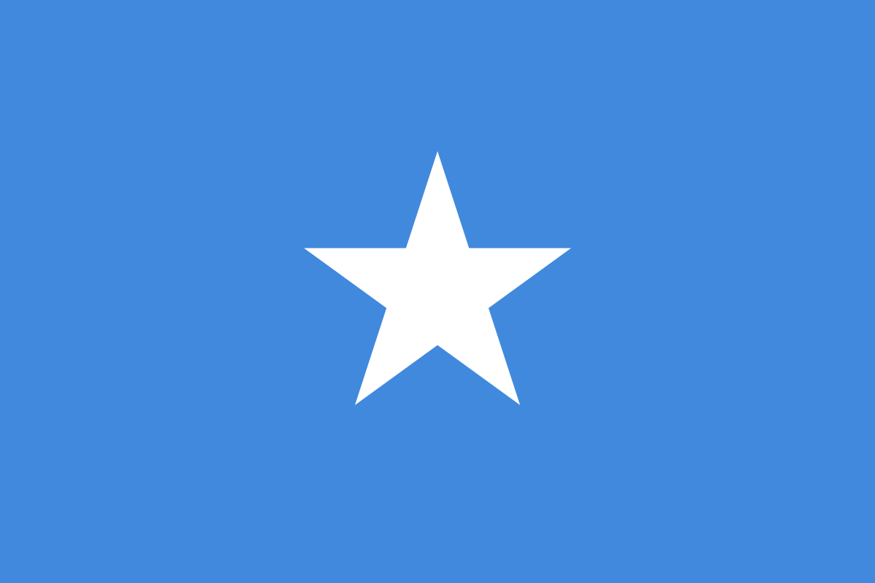
Country: Somalia
Committee: UNICEF
Agenda Items: Fighting Against Social Exclusion and Child Poverty and Providing Education During Emergencies
Somalia which was created in 1960 from a British protectorate and Italian colony, currently has a population of 15.89 million. This country which has an area of 637,657 km² takes place on the Horn of Africa, and is bordered by various countries such as Djibouti, Ethiopia, Kenya, Gulf of Yemen and the Indian Ocean. Furthermore, it is ruled by the federal parliamentary system where the power of the government is divided between the national (federal) government and the state, and the local governments. Somalia is a part of the Arab League and is classified as a least developed country by the Department of Economic and Social Affairs of the United Nations with the poverty rate of 73% of its population and its youth unemployment rate of 67%, which is one of the highest in the world. Somalia has a traditional economic system which means that the majority of the population engages in agriculture, yet the main economic activity of the country is not crop farming but livestock raising. The health system of the country is weak and poorly resourced which has caused 3.2 million women and men in the country to be in demand of emergency health services. Moreover, there is a reasonably small amount of access to educational supplies, which is also a crucial problem to be realised. Some UN organisations such as UNICEF are working on overcoming these kinds of problems with the help of some operations or conferences to raise awareness. In addition, UN has been working in Somalia through the United Nations Operation of Somalia (UNOSOM) since 24 April 1992.
Children are being affected profoundly due to Somalia’s fragile political and economic situation. More than 3 million children in Somalia are excluded from their schools, for their families aren’t able to afford their school fees. Alongside poverty, some other problems such as long distances to school, safety concerns, social norms favouring boys stop parents from enrolling children, particularly girls, in school. Even children who make it to school have various problems such as overcrowded classrooms, water and sanitation facilities that are inadequate, lack of educated teachers and hard access to essential school supplies. Additionally, some natural disasters such as drought, floods, cyclones, and climate-related diseases and epidemics wreak a havoc on education as it is hard to sustain education in these kinds of conditions. These conditions also cause a damage on the future of the country.
UNICEF is dedicated to work for the viability of education despite the poverty issues or during emergencies. It has been working in Somalia to help children in vulnerable conditions in different ways. Initially, it is mobilizing the curriculum for children to attend school without actually going there. Secondly, it is providing educated teachers, learning materials and is strengthening the curriculum for pupils. Besides, they provide significant support to children and lower the effects of crisis by sustaining education. Targets that are aimed to be done by UNICEF in Somalia by 2022 include providing psychological support to 230 thousand children and helping 220 thousand children access and attend to educational services. A thing that Somalia may prefer doing during crisis or whilst lowering impacts of poverty and social exclusion of children might be creating them groups where they can play educational games and interact with each other. This would probably be helpful since it is proved by pedagogues that playing games support self-development of children and it is a crucial right of children. Furthermore, applying some rules and regulations about sending children to school and monitoring people’s actions might be absolutely valuable, for it is hard to keep people under control without a reasonable amount of pressure. Another thing that can be done by the country may be establishing some civil organisations in the country to raise awareness and increase the self-sufficiency of the country with the help of volunteers by conducting some operations, which will probably show its impacts on issues about children. These helps are deemed to be absolutely beneficial for the nation’s future and if further help can be provided, a significant amount of these problems will have been avoided in the short run.

Resources
https://www.unicef.org/somalia/education
https://somalia.savethechildren.net/content/child-poverty
https://www.worldatlas.com/articles/what-type-of-government-does-somalia-have.html
https://www.bbc.com/news/world-africa-14094503
https://www.who.int/hac/donorinfo/somalia.pdf
https://www.un.org/development/desa/dpad/least-developed-country-category-somalia.html
https://climateknowledgeportal.worldbank.org/country/somalia/vulnerability
https://www.unicef.org/appeals/somalia

