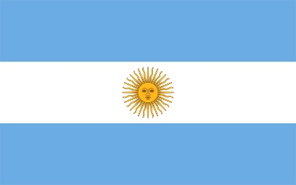
Committee: UNICEF 2 Junior Committee
Country: Argentina
Agenda Item: Fighting against social exclusion and child poverty; Providing education during emergencies
Argentina is the eight-largest country in the world, second largest in Latin America and the largest Spanish speaking one which is located in South America that is bordered by the Atlantic Ocean and covers most of the Southern Cone. Initially populated by the Spanish Empire who passed down their language to the country, Argentina today is a charming region, holding the highest literacy rate in South America and fascinating culture. While joining United Nations on 24th of October 1945, Argentina has played an active role in the defense and promotion of International Peace and Security, Human Rights and Sustainable Development.
Today, there are more than 2.2 billion children on earth and approximately 4 million cases of child abuse and neglect involving almost 7 million children are reported each year. Children all around the globe are victims to abusive households, having to face with social exclusion and poverty, while also being deprived from their rights such as education. Children around the world get deprived of their rights because of natural disasters that are not given proper attention. Considering that the main causes for these are the situation of the country they are located and lack of education; children’s rights are best preserved and respected in wealthy countries such as Iceland, Switzerland and Finland according to a new United Nations-based study.
Argentina has done much to ensure children’s right to education and ratified the United Nations Convention on the Rights of the Child in 1990, integrating it into its national constitution since 1994 that covers health, education, leisure and culture. Moreover, the country has launched “Plan Familia”; a nation-wide programme aimed at assisting poor families so that their children can attend school and receive primary health care. Some of the current plans Argentina is offering include digital tracking of labor and companies, along with increasing the amount of military property in order to keep civilian possessions preserved.
Resources:
- humanium.org
- healthychildren.org
- un.org
- imuna.org
- dataworldbank.org
- dataexplorer.unescap.org
- sesric.org
- knoema.com
- cia.gov

