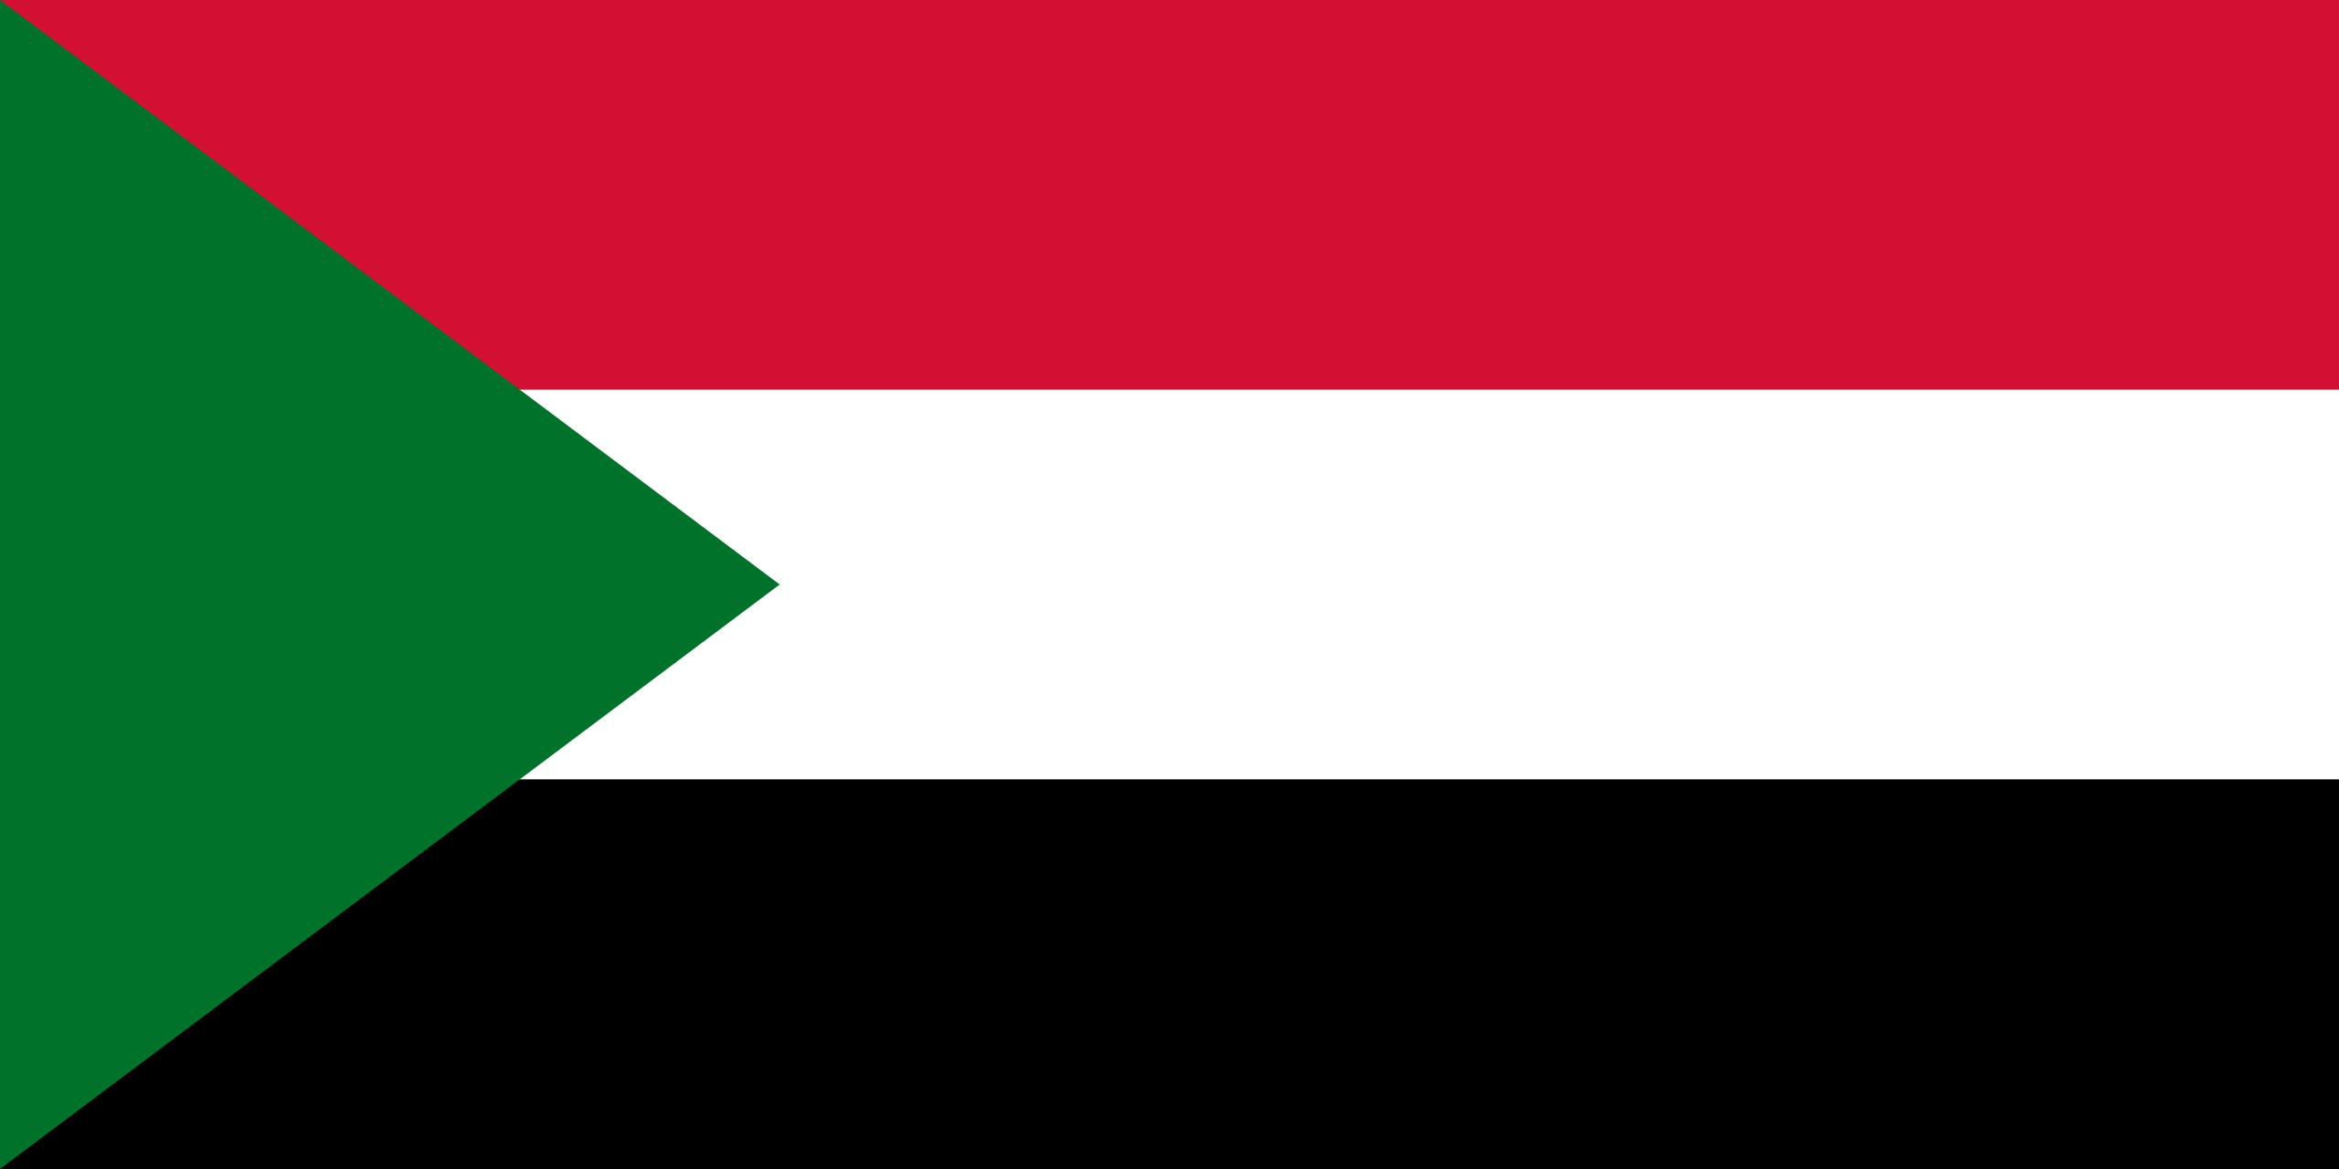
Country: The Republic of the Sudan
Committee: UN WOMEN
Agenda Item: Elimination of the Raising Domestic Violence During Covid-19 Pandemic
The Republic of the Sudan is a country located in Northeast Africa. It has access to the Red Sea which makes its location geopolitically important. The capital city is Khartoum, yet the largest city of the country is Omdurman, 12 kilometres away from the capital. Total population of the Republic of the Sudan is 44.9 million and gender ratio is expectedly ½. The majority population being Nubian, Arab settlements Arabised the population.
While the people of Sudan were struggling for independence from Britain in 1952, The Sudanese Women’s Union (SWU) was found by Fatima Talib, Khalida Zahir and Fatima Ahmed Ibrahim, forming its first executive committee. The SWU not only fought for women’s rights in Sudan, but also spread its actions across Africa. It also organised people around Africa to protest against apartheid, especially in Zambia, Namibia and South Africa.
Women in Sudan got their political rights in 1964, in the aftermath of the Sudanese Revolution. Fatima Ahmed Ibrahim, a founder member of The SWU, became the first woman elected member of the Sudanese Constitutional Assembly (according to Caitlin Davies and Middle East Monitor, the first woman member of any African government).
In August 2019, while the Sudanese government was transitioning to democracy, women played a significant role. As so, Global Fund for Women estimates that women make up for approximately 70% of protesters. The iconic leader is Alaa Salah as “Woman in White” or “Lady Liberty” who gave a speech at the United Nations Security Council arguing that women should be represented equal to men.
It is also worth pointing out that female member percentage of the Republic of the Sudan between 1997 and 2018 was 30.52 while the world average was 21.88 at the same period.
The first case of Covid-19 was reported on March 13, 2020. Since then the Republic of the Sudan reported 44,406 cases and 3,206 deaths related to the virus as to December 10, 2021. The government of the Sudan took measures like partial lockdown, contact monitoring, risk communication, social distance, quarantine and isolation to prevent the spread of the disease. Also, 3.276.654 vaccine doses have been administered.
Going through the pandemic, domestic violence against women rose all around the world including Sudan. This trend was named “shadow pandemic” by UN Women. According to the Report of the Secretary-General on “Intensification of efforts to eliminate all forms of violence against women and girls”, prior to the pandemic, almost 18 per cent of women and girls between 15 and 49 years age experience domestic violence by an intimate partner over 12 months.
The Republic of the Sudan took measures to decrease the effects of “shadow pandemic”. The Ministry of Labour and Social development has proposed a 6 billion SDG (110 million USD) programme to support the population. The Social Welfare Ministry introduced a hotline to support domestic violence victims psychologically and socially. There is also The No to Women Oppression Initiative started by Ihsan Fagiri. Rallies took place in Khartoum and Babanusa.
The Sudanese officials are also interested in cooperating. Sudan joined international movements and campaigns to raise awareness about domestic violence and prevent abuse from happening. 16 Days campaign, including 145 other member states, was just one of the organisations Sudan was interested in. Since 2012, there are still events organised within this campaign to this day.
Even though some actions took place to ensure women’s rights, we know it is not enough. We strive for more measures and organisations to take place. We would like to highlight that Sudan is open to any kind of support to help Sudanese women have better conditions to live in. We are also ready to help to any nation struggling with women’s rights.
The Republic of the Sudan acknowledges that Covid-19 pandemic not only brought health issues but also problems about domestic violence and human rights. We would like to state that we are open to cooperate to create a safe place for women.

