Committee: North Atlantic Treaty Organizations
Country: Hungary
Agenda Item(s): North Macedonia Ethnic Rivalry

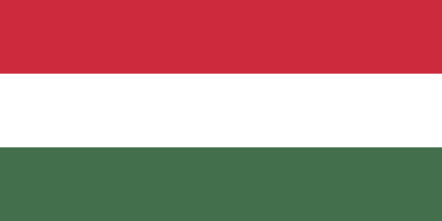
Hungary is a landlocked country in central Europe. Hungary shares a border with Slovakia, Ukraine, Romania, Serbia, Croatia, Slovenia, and Austria. Hungary has a population of 9.7 million, consisting of ethnic Hungarians and 13 minorities acknowledged by the government. These minorities have been defined in the Hungarian Act on the Rights of National and Ethnic Minorities which was adopted in 1993, hereinafter called the Minority Act.
The Minority Act’s scope of application is limited by the criteria which contrast the UN Human Rights Committee's (HRC) interpretation of the term. The required qualifications are :
- The community or individual has to be a citizen of Hungary.
- The community or individual’s ethnic group has to have a history of at least one century of living in Hungary.

As seen, the Minority Act does not apply to refugees, immigrants, foreign citizens settled in Hungary, or persons with no fixed abode. Hence, it doesn’t meet the scope which was seen necessary by the HRC’s Article 27 by the ICCPR (International Covenant on Civil and Political Rights). Hungary was criticized by the CERD, for including what CERD describes as a restricted provision. The minorities who fit the description are as follows: Armenians, Bulgarians, Serbians, Croatians, Germans, Greeks, Poles, Roma, Romanians, Ruthenians, Slovenians, Slovaks, and Ukrainians.

The rights attained by the minorities consist of a policy unique to Hungary: Any minority has the right to establish a minority municipal government or local minority self-government in townships, towns, or the districts of the capital city, as well as national minority self-government. These governments are responsible for providing bilingual education (in the concerned minority’s mother tongue and Hungarian). They are also responsible for establishing educational, cultural, scientific institutions of their own. They also can initiate the creation of “minority classes” at the request of legal representatives of 8 students belonging to the same minority group. Thus, giving minorities the right to have cultural autonomy.
In conclusion, Hungary deserves praise for its efforts to recognize and accommodate the diversity of its population, through the enactment of the relevant human and minority rights norms. Nevertheless, Hungary should widen the range of ethnic or national minority groups acknowledged.
Considering the agenda item, Hungary has been a member of NATO since the first wave of post-cold-war enlargement, 1999. Subsequently, the friction from FYORM necessitated the interventions of NATO. Therefore, Hungary took an active part in the operations by sending troops.
Hungary believes the attainment of rights needn't be through extremist actions and will side where democracy is.

Sources:
https://www.nato.int/docu/update/2003/03-march/e0331a.htm
https://en.wikipedia.org/wiki/Hungary
https://www.ecmi.de/fileadmin/doc/JEMIE04Walsh30-07-01.pdf
https://www.cilevics.eu/minelres/NationalLegislation/Hungary/Hungary_Minorities_English.htm
https://en.wikipedia.org/wiki/Operation_Essential_Harvest
https://en.wikipedia.org/wiki/Operation_Amber_Fox

