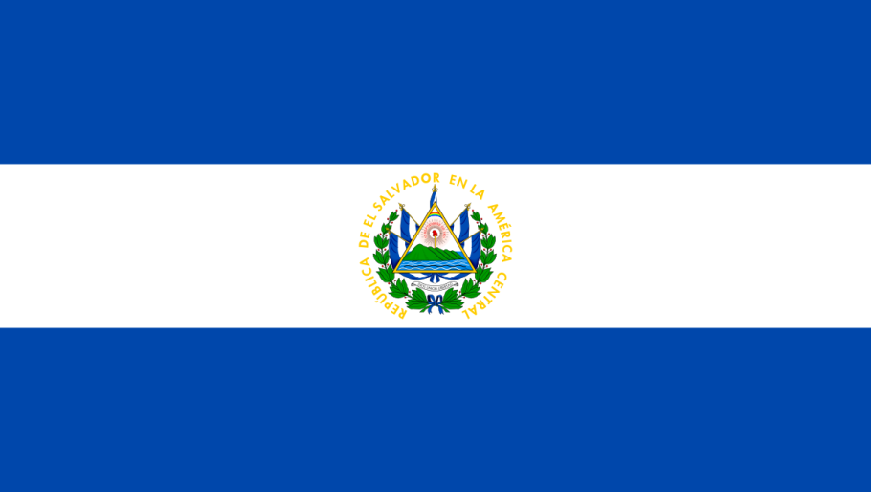

Country: El Salvador
Committee: CSW
Topics: “Assurance of Equal Pay for Services Equal Derivative Values Between Men and Women”, “Extending The Reach of Economic Leadership of Women in Developing Countries”
School: Emine Örnek Highschool

Honorable chair, esteemed delegates;
I am a delegate of El Salvador. El Salvador is country in Central America and, geographically, is part of continental North America and has access to sea. El Salvador has borders with Guatemala, Honduras and Pacific Ocean. The capital city of El Salvador is San Salvador and it is also the largest city in this country. El Salvador has a population around 6.8 million. The Flag of El Salvador consists of three horizontal blue-white-blue stripes, respectively. This sorting symbolizes the sky, peace and the ocean, dividing the flag horizontally into three equal parts. The blue color in the flag represents the sky and the two great oceans of Central America. The white color represents peace and solidarity with the world.
First of all, as we know Women Rights in Economy is one of our topics in CSW and a common problem our world is facing. The idea of women getting less paid and having less rights then men is not right and should be stopped. Throughout the years women faced with lots of criticism about why they should work and get paid less then men. This was caused by stereotypes about women. Even though all humans should get acted the same and they are equal, women were always thought that they were weak. As a result their rights were taken from them and they couldn’t have a chance to prove other people wrong. This caused insecurities and lack of faith in themselves. With nobody believing –including them- to women, activities of women in economy got less and less. However we should change that as a world, we should change the idea of women being “weak” and giving them more oppurtunities to prove themselves that they can be and do so much more then they do right now.
El Salvador screamed out for change. We are a country in which the wage gender gap between men and women is 14 percent and where women do not have the same access to education as men. Five out of every 10 girls drop out of school to help in the home and 61.3 percent of the illiterate population is female. At the same time, women represent 76.8 percent of the inactive economic population. Of these, 42.8 percent are categorized as engaging in “home work”. Women occupy 29 of the 262 existing mayorships and there are 18 female representatives among the 84 seats in the General Assembly. The law dictates, among other things, that women and men obtain the same salary for the same work and that the value of domestic labor, paid or unpaid, be recognized. It also provides guarantees for rural women. For example, it regulates land titles.
Men and women in El Salvador have the same rights to vote, run for office, organize, etc. Although the involvent of women in politics has traditionally been low, it has increased in recent years: according to a 2007 CEDAW report, the Government of El Salvador had pushed for increased involvement in municipalities, resulting in increased participation at this level. As of 2015, women made 32.10% of the Parliament. In order to improve overall participation among women, the Association of Salvadoran Women Parliamentarians and ex-Parliamentarians (ASPARLEXSAL) was formed in 2003. With support from the United Nations Democracy Fund, the Association offers training and resources to women looking to get involved in politics.
If women in a country do not have the same rights as men do the country is not developed.
El Salvador wants to thank all delegates about their effort on trying to find solutions.

