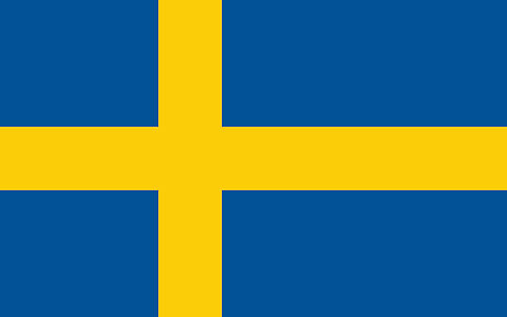

Country: The Kingdom of Sweden
Comittee: Food and Agriculture Organization of the United Nations
Agenda Item: Ensuring Suistinable Food Porduction and Distribution to Accomodate the Increasing Wold Population

Population size has been a long determinant of total food demand around the world, as a cause and consequence of slow development in regions. However, in recent decades, world population couldn’t seem to be supporting the amount of food production. “In 2018, the world’s population was nearly 2.5 times as large as in 1961, yet the global food supply had more than tripled over the same period (FAO, 2021). ” (i.Quoted from, www.un.org.development.desa.pd/files/undesa_pd_2022_global_population_growth.pdf ‘Part D’ Chapter 18.) The one that has come with an undeniable enviromental consequences, such as uncontrolled amount of food waste. “Today’s system of global food production seems to be unsustainable: current practices cannot be scaled up to feed a growing population and accommodate changes in consumer preferences without causing further grave damage to the environment.” (ii. Part D, Chapter 18)
‘How to Sustainably Produce and Distribute Food’
- Educating Slow Developing Regions on Human Reproducing
Considerating the speed of increasing world population, education of reproducing in undeveloped or slow developing regions in a few decades must be necessary for future generations. In order to produce a needed amount of food without harming the environment, society first needs to have considerate the amount of reproducing that is going on.
- Consideration of Eating Habits
Having a healthy diet takes a big part in a healthy life. A healty diet contains a lot of protein, and one of the easiest ways to have more protein is to have meat. Studies had shown that producing meat causes a lot of carbon emission. To reverse the enviromental damage, considerating eating habits and producing less meat might help more than enough for the food industry.

‘Sweden’s Proposed Amendments to Sustainable Produce Food’
Sweden is often seen as a leading country in animal welfare and legislation, but some recent amendments to the legislation are perceived as relaxing animal welfare requirements in order to improve the competitiveness of the relevant industry and of farmers.(Quoted from https://agris.fao.org , journal article of Thirty Years of Changes and the Current State of Swedish Animal Welfare Legislation )
“Carbon Emission in Food Production” Meat industry has taken up 60% of all greenhose gases from food, making it a bigger cause of carbon emission in food production. (remarked) Mostly lamb (39.2 CO2 Kilos Equivalent), beef (27.0 CO2 Kilos Equivalent) followed with cheese (13.5 CO2 Kilos Equivalent) and pork (12.1 CO2 Kilos Equivalent ).
According to https://agris.fao.org (Journal article of Thirty Years of Changes and the Current State of Swedish Animal Welfare Legislation ) , Sweden has changed the non-behaving system of national animal welfare regulations relating to horses, cattle and pigs between 1988 and 2019 and the consequences of the intended animal welfare level.
SCAW, was established in 2008 to gather expertise, and coordinate activities, in the field of animal welfare.(remarked) As a developing welfare system, SCAW (Swedish Centre for Animal Welfare) is now serving in sweden as one of the most well-known welfare care centre. SCAW is a contact point fort he goverment and other authories.
As a newly developing welfare-care system, Sweden sicerely appreciates help from all across the world, mainly Swedish professionals.

References:
https://www.un.org/development/desa/pd/sites/www.un.org.development.desa.pd/files/undesa_pd_2022_global_population_growth.pdf
https://www.eufic.org/en/food-safety/article/food-waste-in-europe-statistics-and-facts-about-the-problem?gclid=EAIaIQobChMIzauFxbG2_gIVSPyyCh0DdQXnEAAYASAAEgIRgfD_BwE
https://citeseerx.ist.psu.edu/document?repid=rep1&type=pdf&doi=8062624a7ae9290c63ccaa4fcfdb84f551987272
https://agris.fao.org/agris-search/search.do?recordID=CH2022143281
https://food.ec.europa.eu/safety/food-waste/eu-actions-against-food-waste/eu-platform-food-losses-and-food-waste_en

