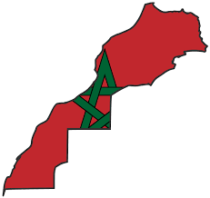Country: Morocco
Committee: World Health Organization (WHO)
Agenda Item: Uncontrolled use of technology and digital obesity
The main language of Morocco is Arabic. Morocco’s capital city is Rabat. The form of government of Morocco is a constitutional monarchy. Morocco has the fifth largest economy in Africa. The first prime minister of Morocco is Mbarek Bekkay. Morocco’s population is 37.08 million.

The fact that the amount for information and content available is growing every day is called digital obesity. The result of digital obesity is seen in the world as follows: distraction, has caused events such as a decrease in face-to face, communication and avoidance of taking responsibility, November muscles aches and physical problems and negative impact of academic development.

Awareness of mental and physical fatigue in the face of digital obesity caused by exposure to information notifications and data flow that flow in a dense and disorganized way without fast integrity in digital environments, without connection with each other, limits have been placed on the time spent using technology.

Innovation, particularly in the digital sphere, is happening at unprecedented scale. Even so, its application to improve the health of populations remains largely untapped, and there is immense scope for use of digital health solutions. WHO is harnessing the power of digital Technologies and health innovation to accelerate global attainment of health and the well-being.

In order to prevent digital obesity, news that prevents the unnecessary flow of information and ensures its accuracy can be allowed.

