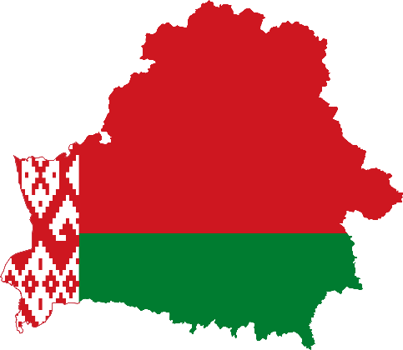
Country: Belarus
Committee: WHO (World Health Organization)
Agenda Item: Uncontrolled use of technology and digital obesity
Belarus, officially Republic Of Belarus, is one of the countries had left the Union of Soviet Socialist Republics, simply the Soviet Union. It gained its independence after it left Soviet Union, at August 25 1991. Since 1994, Alexander Grigoryevich Lukashenko has been the president of Belarus. Belarus has been in UN since 1945 as Soviet Union until its independence. After it left Soviet Union, it continued being in UN as the country Belarus. When it was still in Soviet Union, it was the smallest of the three Slavic republics included in the Soviet Union. Belarus also has some different names like White Russia, Belorussia and ex. In Belarus, there are Belarusians, Russians, Polish, Ukrainian and other kinds of ethnic groups with 9.449.323 population (<- according to the 2023’s researches.)Both Belarussian and Russian are official languages of Belarus.
In 2020, the World Health Organization formally recognized addiction to digital technology (connected devices) as a worldwide problem. Uncontrolled use of technology and the internet brings various behavioral addictions that can harm people both physically and psychologically. The problems caused by technology addiction include physical complaints such as eye burning, pain and stiffness in the neck muscles, poor body posture, numbness in hands, and physical weakness. It doesn’t affect only adults; also effects children. It makes children more aggressive and throw tantrums. Digital obesity is basically about over consuming (of information), not giving enough rest. It is basically the same as constantly eating, never doing anything else.
There are a lot of study about effects of using technology and digital obesity on adolescence, children and also adult. This problem needs to be approached holistically. WHO has been conducting activities related to the public health implications of excessive use of the Internet, computers, smartphones and similar electronic devices since 2014 in response to concerns expressed by professional groups, WHO collaborating centers, academics and clinicians about the public health relevance of health conditions associated with excessive use of the Internet and other communication and gaming platforms.
Belarus is among the world's scientifically and technologically advanced nations.
The total technology usage time during the day (e.g., watching television and playing games on computers, tablets, and mobile phones) should be limited to 1-2 hours. Care must be taken that children aged 2 years or younger not be allowed to face the screen. Television and technological equipment connected to the internet should be kept away from the bedroom. If one’s children are allowed to use technological devices, the use of these devices must be subject to certain rules. Adults must be careful about themselves too. Because it’s not something only on children.

