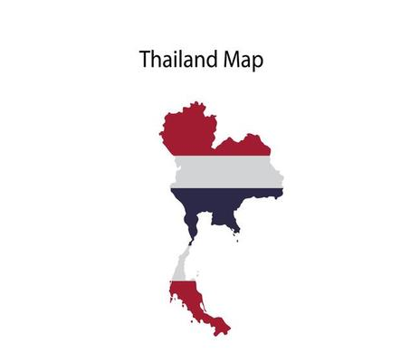
Country: Kingdom of Thailand
Committee: FAO ( Food and Agriculture Organization)
Agenda Item: Ensuring sustainable food production and distribution to accommodation the increasing world population
Kingdom of Thailand was established in the mid-14th century. Known as Siam until 1939, Thailand is the only Southeast Asian country never to have been colonized by a European power. A revolution in 1932 led to the establishment of a constitutional monarchy. Thailand is ruled by constitutional monarchy. Their ruler is Vajiralongkorn. The official main language spoken in Thailand is Thai. The country is also a home to 70 more languages. Thailand has the second largest economy at the Southeast Asia. Capital city of Thailand is Bangkok. Thailand is a member of ASEAN. The industrial and service sectors are the main sectors in Thailand. Thailand has entered the UN in 1945. Thailand’s population is 69,794,997. Upper middle-income Southeast Asian economy; substantial infrastructure; major electronics, food, and automobile parts exporter.
Today, ensuring sustainable food production and distribution is one of the most important challenges of the world. This challenge on the one hand includes eradication of hunger in different parts of the world and maintaining the food safety and sustainability on the other for the rest of the world. The challenge would be to feed 10 billion people in 2050. Because of the deficiencies of the global food policies, today many children have died from hunger. In that sense, ensuring sustainable food production and distribution in a world whose population is gradually increasing is standing in front of the UN member states for their active cooperation for the solution of food security challenge.
Over the past half century, Thailand’s agricultural sector has moved beyond self-sufficiency to making the nation a major food exporter. Today, Thailand plays an important role as a regional food center and ‘kitchen of the world’, feeding its own population and contributing to the food security of people in and outside of Asia. Indeed, Thailand stands as the world number one exporter of rice sharing over 30 percent of the global rice trade volume, in addition to canned tuna fish, natural rubber, etc. FAO’s direct support – or field programme in Thailand – was initially mainly supported by UNDP which had provided since 1950 In addition, FAO’s Technical Cooperation Programme (TCP) – funded from the Organization’s own regular programme – started in 1977. Another financing modality for field programmes started in 1997, the worldwide TeleFood Special Fund, under which Thailand implemented 36 projects until now. In addition, Thailand has benefitted from nearly 100 global/regional projects in which the country participated.
Thailand became a member of the Food and Agriculture Organization of the United Nations on 27 August 1947. Over the last three decades, and moving gradually from a recipient into a donor country, Thailand has contributed significantly to FAO to fulfil its mandates. The keen interest and personal involvement of Thailand’s Royal Family in agricultural and rural development in the country have been crucial elements of the evolving partnerships between Thailand and FAO. In this connection, FAO has awarded the Ceres Medal to Her Majesty the Queen in 1979.
The hierarchy of strategies for reducing food losses and waste are in descending order source reduction, reusing or reprocessing surplus foods, recycle food as feed for animals, recover the energy as biofuels, nutrients as compost, or raw materials for industry, while as last resorts one may consider recovering the energy by incineration or dumping as garbage in landfills.

