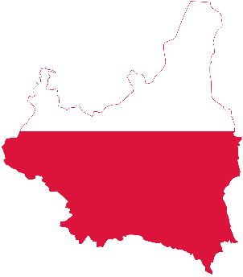
Country: Poland
Committee: The UN Refugee Agency (UNHCR)
Topic: Promoting and protection of human rights in the situation of human trafficking

Poland, officially the Republic of Poland, is a country in Central Europe. It is divided into 16 administrative provinces called voivodships, covering an area of 312,696 km² (120,733 sq mi). Poland has a population of around 38 million and is the fifth-most populous member state of the European Union.

Human trafficking involves the use of force, fraud, or coercion to obtain some type of labor or commercial sex act. Every year, millions of men, women, and children are trafficked worldwide – including right here in the United States. It can happen in any community and victims can be any age, race, gender, or nationality.

Poland is a source and destination country for men and women subjected to trafficking in persons, specifically conditions of forced labor and for women and children in forced prostitution. Men and women from Poland are subjected to conditions of forced labor in Italy and Sweden. Women and children from Poland are trafficked for forced prostitution within Poland and also in Belgium, Germany, Italy, the Netherlands, Spain, Portugal and Sweden. Women and children from Moldova, Ukraine, Bulgaria, Romania, Belarus, and Russia are trafficked to Poland for forced prostitution. Men and women from Bangladesh, China, and the Philippines are found in conditions of forced labor in Poland. Men and women from Thailand, Nigeria, Iraq, Ukraine, Belarus, Romania, Bulgaria, Moldova, Mongolia, Vietnam, Turkey, Djibouti, and Uganda are found in conditions of forced labor, including forced begging and debt bondage, and also forced prostitution in Poland.

The Government of Poland does not fully meet the minimum standards for the elimination of trafficking but is making significant efforts to do so. The government demonstrated overall increasing efforts compared to the previous reporting period, considering the impact of the COVID-19 pandemic on its anti-trafficking capacity; therefore Poland remained on Tier 2. These efforts included investigating and prosecuting more suspected traffickers. The government adopted a new national action plan (NAP), and the government’s first procurement strategy requiring authorities to ensure forced labor was not used in government contracts. The government identified and assisted more victims, enacted legislation increasing the penalties for trafficking crimes committed against those fleeing Russia’s war on Ukraine, and enhanced protections for unaccompanied children. However, the government did not meet the minimum standards in several key areas. Labor inspectors did not identify any trafficking victims, and overall victim identification efforts remained inadequate. The government also did not increase resources for victim services, thereby constraining overall protection efforts. Authorities lacked a central mechanism to cross-reference and consolidate law enforcement statistics, which may have hindered the government’s ability to track trafficking trends and effectively adapt policy.
We as the country Poland think, to avoid human trafficking they should check peoples Visa’s more often and police should be more careful about human trafficking crimes.

