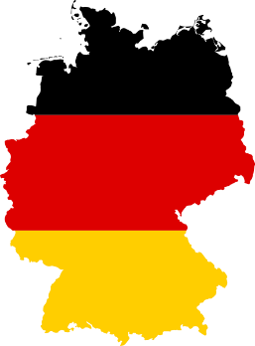
Country: Germany
Committee: FAO (Food and Agriculture Orgaization)
Agenda Item: Ensuring sustainable food production and distribution to accommodation the
increasing world population

Germany is a large country in Central Europe, also the most populous member state of the EU (European Union). It has the largest economy in Europe and the fourth largest economy in the whole world (According to Nominal GDP). Despite all that, it is only the seventh largest country in Europe. The chancellor of the state is Olaf Scholz and the President is Frank-Walter Steinmeier. For history: Pre-Human ancestors were present in the country over 11 million years ago and the first Neanderthal was discovered in a valley of Germany, hinting it was a popular spot for the earliest humans. The Germans formed many empires, kingdoms and republics over the centuries such as East Francia, The Holy Roman Empire, The German Empire, The modern German Republic and more.

Almost 1 out of every 15 kids in developing countries die before the age of 5, usually because of starvation. Although this is a worldwide problem, it strikes Africa the most. More than a quarter of Sub-Saharan Africa is chronically hungry. If one of the undernourished people is a pregnant mother, the child comes to the world undernourished too, which usually leads up to their death at a very young age. Looking at Asia, currently 526 million people there are starving as well.

Since 2002 the Federal Ministry of Food and Agriculture has used a Bilateral Trust Fund (BTF) to assist FAO projects designed to overcome hunger and undernourishment. In 2021, the German government contributed about 1.2 billion euros for the World Food Programme. The government states that throughout the following years Germany will use 1.5 billion Euros every year for food security, agricultural promotion and rural development in partner countries as part of German development cooperation.

ONE WORLD – No Hunger (SEWOH) is the name of the special initiative of the German Federal Ministry for Economic Cooperation and Development launched in 2014, in which policy-makers, businesspeople, scientists and civil society are working in several hundred projects in 35 countries in the goal of zero hunger. The Federal Ministry of Food and Agriculture has also supported a 118 projects for FAO.

Together with German universities, The Federal Ministry of Education and Research support academic training and research programmes on the topic.

