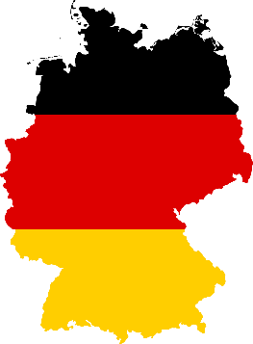
COUNTRY: Germany
COMMITEE: UN Commission on the Status of Women
AGENDA ITEM: Promoting gender equality and empowerment of women

Germany is a European country. Germany’s capital city is Berlin. Its population is 83 million. Germany’s area is 357.588 kilometers. Germany is the second most populated country in Europe Union. Germany is managed by federal republic. Germany’s most populated city is Berlin. Germany has 16 states. Germany has joined the United Nations on September 18th, 1973.
Since 1857, there are women rights all around the world. Communities include women rights in their constitutions. However in many country, still many women die because of lack in women rights. Also in many countries, women can vote and can take parts in politics and in the life. Also 8th March is celebrated for World Women Rights.
On November 30th, 1918, women's right to vote and be elected was guaranteed by law in Germany, and women voted for the first time in the 19 January 1919 elections. Due to this law, since 2018, 20 women politician took part in politics and in country management. German International Cooperation Society (GIZ) were established in 1 January, 2011 and GIZ helped 120 countries.
According to women's rights in Germany, men and women are considered equal. In Germany, a law to protect women against violence was enacted in 2002. Harassment against women is illegal in Germany. However it is really hard to notice and because of this many women live this event.
We, as Germany, think all countries should have strict laws and encourage women to stand up against injustice when it is done to them. We think we should make every women and men equal.

