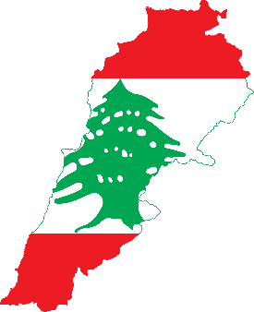
Country: Lebanon
Committee: UN Commission on the Status of Women (CSW)
Agenda Item: Promoting gender equality and empowerment of women

Lebanon is one of the smallest countries in the world. The country, which has hosted some of the oldest civilizations in the world, has contributed to the development of civilization with its historical city-states. The country, which became independent in 1943, was governed by the French Mandate shortly before its independence. The country has a mountainous and rugged terrain. The climate seen in the country is generally described with the Mediterranean Climate and the climate from temperate to cold. Winters are warm and rainy, while summers are hot and dry for many years, it has been one of the leading countries in the Middle East in terms of culture and economy. Lebanon is an Arab and Middle Eastern country on the Eastern Mediterranean coast in Western Asia. Arab identity and culture is dominant in the country.

Traditional values and Middle Eastern habits are anchored in the society, while social pressure has collapsed on some women with all its weight, while others identify themselves with western models and rebel against traditions, but most of the women take care to do this in secret. Working is a more important value for Lebanese women in general, but still the only way for a woman to act independently of her family is marriage. Also, single women have to live with their families until marriage irrespective of their salaries.

Despite some recent reforms, the country's legal system is full of laws that discriminate against women. Lebanese mothers are unable to pass on their citizenship to their children. Issues such as divorce, property rights and child custody are decided by religious laws that heavily discriminate against women. Lebanese laws also does not specifically criminalize rape for marriage, and Lebanon has one of the lowest rates of maternity leave allowance in the world. Lebanon has only 6 female MPs in its 128-seat parliament and women are underrepresented in key workforce fields such as Science, Technology and Engineering. Not surprisingly women's rights in Lebanon are treated like any other pressing issue facing the country. Unfortunately governors temporarily cover up defects without making any drastic changes. So women are trying to protest the political system, where they have been underrepresented for a long time, on the streets.
We, as Lebanon, are aware of our lack of laws which protect women rights. We are open to find long – term solutions to our problems we have mentioned above.

