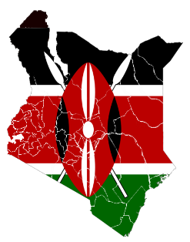
Country : Kenya
Committee : The UN refugee agency (UNHCR)
Agenda Item : Promoting and protection of human rights in the situation of human trafficking

Kenya is a country in East Africa. With a population of more than 47.6 million, Kenya is the 27th most populous country in the World and 7th most populous in Africa. Kenya’s capital city is Nairobi. As of 2020 Kenya is the third-largest economy in sub-Saharan Africa.
Traffickers use violence, manipulation, or false promises of well-paying jobs to exploit victims. Victims are forced to work as prostitutes or to take jobs as migrant, domestic or factory workers with little or no pay.
In African countries there’re more trafficking than usual. Because of its bad economy there are more poor people than usual. In 2020, an international NGO reported that there are between 35,000 and 40,000 victims, in Kenya, of which approximately 19,000 are children victims. The government increased overall anti-trafficking law enforcement efforts. The Counter-Trafficking in Persons Act of 2010 criminalized trafficking and prescribed penalties of 30 years to life imprisonment, a fine of not less than 30 million Kenyan shillings or both.
As Kenya, we need economic aid and more security forces. We can make heavier regulations for human trafficking. We need more sources to distribute that people needs economic aid and provide jobs.

