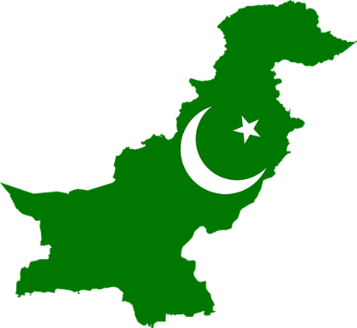
Country: PAKISTAN
Committee: UN Commission on the Status of Women
Agenda Item: Promoting gender equality and empowerment of women

Pakistan is a country in South Asia and is an Islamic government. With a population of over 210 million, it is the fifth most populous country in the world. It has the second largest Muslim community. With an area of ​​882.000 km squared, it ranks 33rd in this area. It borders with India in the east, Afghanistan in the west, Iran in the southwest and China in the northeast. It also has a maritime border with Oman. There are touristic places like Badshahi Mosque, Faisal Mosque, Lahore Fort. Karachi is the most visited city. Currency is Pakistani rupee.
Women's rights are rights that represent equality and freedom. The most fundamental right of women is to be born free and to have equal rights with men. In addition, every woman has the right to freely express her ideas and thoughts. These rights are the fundamental rights of every woman. The protection of fundamental rights is easy in conscious societies. Because women and men must have equal rights.
Pakistan has recognized women's rights. In Pakistan constitution, women are equal with men and there is an article about women and women’s rights.
Article 34 guarantees that women cannot be discriminated against and that they participate fully in social life. Pakistan has signed the Convention on the Elimination of All Forms of Discrimination against Women (CEDAW). Pakistan was the first Muslim country ruled by a female prime minister: Benazir Butto.
On the other hand, most of the population shares the same opinion: radical Islamism. According to radical Islamists, men are superior to women. While men have the right to drive, vote, go out and get an education, women have no right to do so. Feminicide is increasing day by day and women's rights are considered a disgrace in Pakistan. The literacy rate for women remains around 20 percent.
Unfortunately, women's rights cannot be implemented because of radical Islamists and the Pakistani government turns a blind eye to this issue.
Associations and organizations can be established so that women can stay in the religion and belief they want. Severe sanctions may be imposed on those who disregard this right. Radical Islamic associations groups can be closed.

