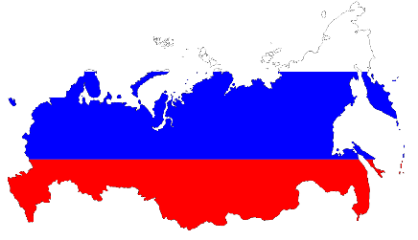
Country: The Russian Federation
Committee: CSW
Agenda Item: Promoting Gender Equality and Empowerment of Women

Russia, or the Russian Federation, is a transcontinental country spanning Eastern Europe and Northern Asia. It is the largest country in the World, encompassing one-eighth of Earth's inhabitable landmass. Russia extends across eleven time zones and shares land boundaries with fourteen countries. It is the world's ninth-most populous country and Europe's most populous country, with a population of over 147 million people-of which 77.9 million are female were 67.65 is male- . The country's capital and the largest city is Moscow. Saint Petersburg is Russia's cultural centre and second-largest city. Other major urban areas include Novosibirsk, Yekaterinburg, Nizhny Novgorod, and Kazan.
Gender equality is a politically complex effort to shape attitudes and policy decisions that endorse equitable distribution of resources among men and women, girls and boys. If women were afforded the same equity as men in the labour market, the global annual GDP could potentially grow by as much as $28 trillion, or 26 per cent by the year 2025.
In Russia, under the Labour law, women have the right to paid maternity leave, paid parental leave, and unpaid parental leave that can be extended until the child is 3.
Also the Constitution of Russia, adopted in 1993, guarantees equal rights for women and men. Even before that, the Bolshevik Revolution granted women’s rights in Russia– including suffrage– in 1917. However, women are still fighting inequality in many sectors, including the professional realm. People in Russia expect women to prioritize motherhood over professional development because of Russia’s low fertility rate. Citing a belief that strenuous jobs pose a threat to women’s safety and reproductive health, the government has barred women from occupations like aircraft repair, construction and firefighting. While the country passed reforms in 2019 to reduce the number of restricted jobs from 456 to 100, they will not come into effect until 2021. However, some of the largest industries, like mining and electric engineering, remain in the barred category.
And Russia is planning on extending projects in the future such as putting out tougher laws to protect women, employers paying women equal to men, giving better access to education for women, removing the barriers that stop women of getting to senior positions in work, and the media portraying women in a more positive way.

