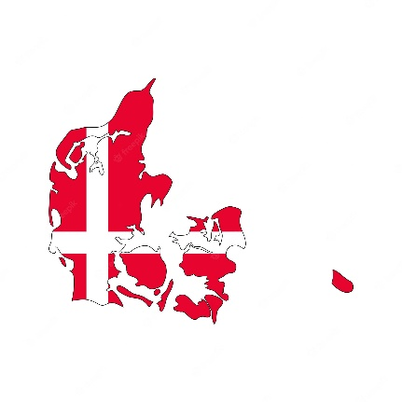
Country: Denmark
Committee: CSW
Agenda Item: Promoting gender equality and empowerment of women
Denmark has extremely high levels of social trust. People trust each other and trust institutions like the government, the monarchy, the hospitals, and the police. Trust is an important part of the business environment, too. These values of trust and community are deeply embedded in Danish culture and society and have their roots in Danish history. Denmark became a constitutional monarchy and announced its independence on June 5, 1849. In 1972, Denmark joined the European Economic Community (EEC) - the leading economic partnership in Europe - which later became the European Union. Denmark was also one of the founding members of the United Nations (UN).
When industrialization began to take place in Denmark about 150 years ago, women quickly became part of the work force, earning their own money, paying taxes, and contributing to financing the Danish welfare system. By the 1960s, a network of Danish day care systems had been established. Today, the percentage of Danish women working outside the home is one of the World’s highest.
Human rights in Denmark are secured by the Danish Constitutional Act (from 1849). This guarantees Danish citizens the right to sleep under a roof, to look for work on equal terms, to express their opinions freely, to organize themselves as they wish, and many other rights. Denmark scores well on the World Economic Forum's gender equality index. Women in Denmark generally work outside the home and pursue careers while raising a family, assisted by the country's generous parental leave and tax-subsidized daycare. Women are well-represented in Denmark's government. About 40 % of the representatives in Denmark's parliament, the Folketing, are female, and so are many of the country's ministers. Since Danish women now receive more advanced university degrees than men, their advancement seems likely to continue in the years ahead.
Danish men also benefit from gender equality. They get more time with their families than in many other countries. Parental leave after the birth of a child can be split between parents, and limited workdays mean it is often the father who picks up children from daycare and prepares the evening meal. A recent OECD survey showed that Danish men do more housework than in any other country in the world, although they still do slightly less than Danish women.
The Kingdom of Denmark has built a trust in the country and its gender equality rate is higher than most countries. Denmark is looking forward to find solutions.

