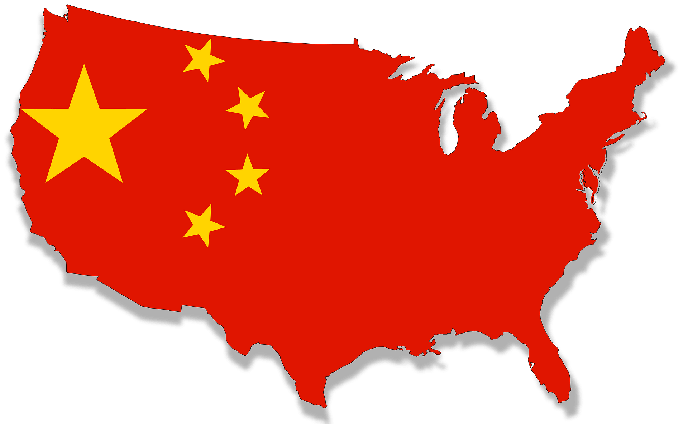
Committee: UNESCO
Topic: Climate change education, training and public awareness
Country: The People’s Republic of China

China, officially the People's Republic of China, is a country in East Asia. It is the world's most populous country, with a population exceeding 1.4 billion, slightly ahead of India. China spans the equivalent of five time zones and borders fourteen countries by land, the most of any country in the world, tied with Russia. With an area of approximately 9.6 million square kilometers, it is the world's third largest country by total land area. The country consists of 22 provinces, five autonomous regions, four municipalities, and two special administrative regions (Hong Kong and Macau). The national capital is Beijing, and the most populous city and largest financial center is Shanghai.

The Paris Agreement, often referred to as the Paris Accords or the Paris Climate Accords, is an international treaty on climate change. Adopted in 2015, the agreement covers climate change mitigation, adaptation, and finance. The People’s Republic of China was one of the signatory countries and the treaty still applies. The People’s Republic of China is also working towards lessening carbon emissions. China aims to peak emissions before 2030 and go carbon-neutral by 2060 in accordance with the Paris climate accord.

As in education the youth about the topic, today, primary and secondary schools across The People’s Republic of China teach environmental topics as part of a “green education” mandate. Topics range from soil desertification, waste separation, biodiversity, the promotion of low carbon travel and responsible consumption, to recycling and behavioral guidance on good “low carbon behaviour”. The primary school (Grades 1- 6) curriculum focuses on fostering young pupils’ curiosity for their living environment, i.e. animals and plants, how they feed and what they need to thrive. Classes called “Nature” with relevant teaching material are taught in some schools. Depending on teacher and school, topics like CO2, climate change, pollution etc. are taught as part of other courses. Some schools organize “Environmental Protection Days” or extra-curricular lectures. Secondary school education (Grades 7 – 9) subsumes education on environmental matters including climate change into the overall science classes like “Chemistry’, “Physics”, “Geography”, “Life Science”. The general approach to the topic is a utilitarian one embedded in the argument that the environment has to be protected in order to continue the economic development of China and secure the well-being of its people, current and future generations.

As we bring this to a conclusion, we would like to state one or two methods to improve the topic. Young children should be taught that climate change is a topic that concerns all of us. We, as all humans, should do something individually to achieve something great together. Even if one person turns on us, we all lose this war with ourselves. The People’s Republic of China is looking forward to coming up with more policies and possible solutions for this topic.

