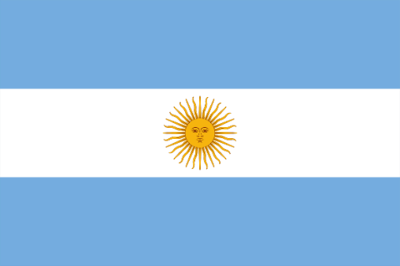
Committee: JUNIOR UNWOMEN (United Nations Entity for Gender Equality and the Empowerment of Women)

Agenda Item: Gender Pay Gap

Country: Argentina

As Argentina, we are proud to be on this committee. We also want to find solutions to the problems that we will talk about in this committee.
Although women play an important role in every country, they are not seen as equal to men. Unfortunately, inequality between men and women started in the past and continues today.
This can be understood by looking at women's salaries, especially in underdeveloped countries. However, they do not receive the same salary or advancement in their careers. Worldwide, because women are more advanced than men in education, the wage gap between men and women has reached twenty-two percent. This is unfortunately not just in salaries, but in many other criteria as well. People are slowly starting to dwell on these issues.
As the UN, we need to take action for this situation.
Unfortunately, this situation affects quite large audiences in Argentina. We are ready to cooperate with other members to find solutions to these problems and we can say stop to this inequality.

