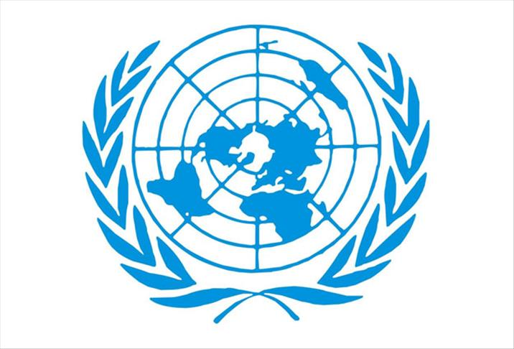

Committee: United Nations International Children’s Emergency Fund
Topic: Fighting Against Social Exclusion and Child Poverty, Providing Education During Emergencies
Country:Sweden
Delegate: Eda Halaç

First of all we are very honoured to participate this extinguished conference and be the delegate of Sweden. As representor of Sweden, we hope to find permanent solutions to the problems we are facing as a whole world.

My country is Sweden. In Sweden there are also social exclusion and child poverty. The number of social exclusion and child poverty has slightly decreased during recent years. Besides Sweden has highest child poverty rates after Spain. Sweden has resolution targets for this problems.

These objectives are:
. to facilitate participation in employment and access by all to resources, rights, goods and
services
. to prevent the exclusion of people from work
.to help the most vulnerable
.to mobilize all relevant bodies.

In addition, Sweden’s welfare system reduces child poverty across the country. Sweden offers a standardized minimum income for all its citizens and provides about 60% to 70% of the average wage in Sweden. Swedish law also allows all employees to earn 25 paid vacation days and 16 public holidays each year.

Likewise Sweden gives importance to education, as well as in emergency situations and draws maps in their school life for these Sweden are planning to move forward in training and still further carry forward problems. In response to the deep inequalities exposed by the COVID-19 pandemic, with devastating impact to children, Sweden’s flexible funding was enabled UNICEF to respond quickly and deliver services to provide essential services for children in the poorest countries and communities.
Additionally, Sweden provided lifesaving thematic funding to child protection and water sanitation and hygiene programmes and contributed US$43 million to 19 UNICEF appeals, including the global COVID-19 appeal, several large-scale emergencies including those that are underfunded. Sweden is not only doing this, it is also making progress in the field of education.

Aware of all of these problems the delegation of Sweden would be honored to take place and discuss these important topics. We wish to talk and find sensible solutions to help the countries in need. If we all cooperate, with no doubt, we can protect our children and their futures.

