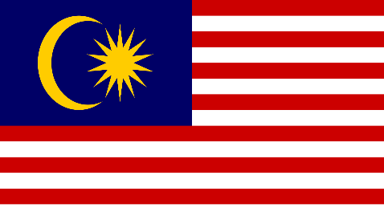
Committee: UNICEF
Agenda Items: Fighting against social exclusion and child poverty & Providing education during emergencies
Country: Malaysia
It’s an undeniable honour to be able to represent Malaysia. We are looking forward to discussing these important topics and finding solutions in the best way we can.
Malaysia is a country which is located in Southeast Asia. The federal constitutional monarchy consists of thirteen states and three federal territories, separated by the South China Sea into two regions, Peninsular Malaysia and Borneo's East Malaysia. Peninsular Malaysia shares a land and maritime border with Thailand and maritime borders with Singapore, Vietnam, and Indonesia. East Malaysia shares land and maritime borders with Brunei and Indonesia and a maritime border with the Philippines and Vietnam.
Malaysia is a dangerous country for a natural disasters. While Malaysia is generally spared severe natural disasters such as earthquakes, volcanic eruptions, and typhoons, it faces floods, landslides, and severe haze. In the past years, it has experienced several extreme weather and climatic events, ranging from thunderstorms to monsoonal floods but we also have laws like the National Security Council (NSC) Directive No. 20 promulgated in 1997 states the mechanism on the management of disasters including the responsibilities and functions of the various agencies under an integrated emergency management system.

About child poverty. The UNICEF report says that: “The review also highlights Malaysia’s success in reducing absolute poverty.” So we can say that we are good at it. In Malaysia that facilitated effective action to reduce poverty, from the New Economic Policy of the 1960s to the Government Transformation Programme (GTP) that commenced in 2009. Also, the report says” Malaysia is one of the countries with the smallest incidence of poverty in the Asia-Pacific region” too. To sum everything up, we believe that Malaysia always has a good answer even what the problem is.

We are hoping to find logical solutions.

