Submitted by: The United States of America
Committee: The Disarmament and International Security Committee (DISEC)
Topic: The Issue of Afghanistan
Delegate: Vagif Huseynov

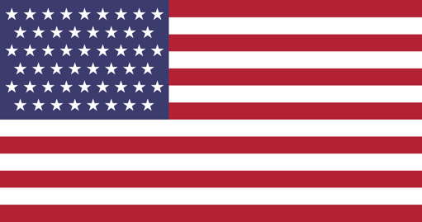
Position Paper

The current issue on hand in Afghanistan deeply saddens and worries the United States of America. Starting from 1979, America has had strong connection with the conflict, supporting and providing independent forces with means to defend themselves and the territorial integrity of Afghanistan during the Afghan-Soviet war. For 10 years, the Soviet Union attempted to take over the country, pouring a lot of weaponry, manpower, and time into bringing down the government of Afghanistan at the time.

Ever since then, upon the completion of the Afghan-Soviet war, the United States of America completely stopped all affiliation with the conflict and left the matter for the state of Afghanistan to handle. However, the emergence of Taliban in 1996 heavily hindered the self-development of Afghanistan, resulting in the complete takeover of the country by Taliban forces. Until 2001, with the tragic incident of the 9/11 attacks, America continued not to intervene with the conflict and takeover of the country. Upon the tragic attack, resulting with the death of 2,977 and injuries of 6,000+ of innocent lives, a series of missions were initiated by the United States of America and a myriad of soldiers were deployed into the country to take control of the situation and stop the terror of the self-recognized, terror group. Upon the intervention of American forces, Taliban had been defeated and peace and security had been restored in the region. A secular, democratic government had been set up under the rule of Hamid Karzai and supervision of the United States of America starting from 2001.

Ever since then, America has invested billions of dollars into the infrastructure as well as counter-terrorism programs of Afghanistan, attempting to set up a foundation whereby Afghanistan can build a solid state with proper defense to guarantee the security and prosperity of their citizens. In addition, the air forces have been supporting the military of Afghanistan to guarantee their territorial integrity.

Upon the reemergence of Taliban in 2003, the United States of America continued supporting the government of Afghanistan in the conflict, sending up to 140,000 American soldiers at its peak to help with the conflict against the terrorist organization. Starting with the Trump administration in 2020 and continuing with the Biden administration in 2021, America had announced the end of the war, and called for the withdrawal of all American troops and forces in the country. The United States of America has stayed neutral since and not displayed any action.

On an international level, the takeover of Afghanistan by a terrorist organization rightfully has startled the community. With that, the security and peace of neighboring Middle Eastern country has been put in jeopardy. By the same token, attempt of peace and possible end to the arms race has also been placed under doubt because of increased hostility.

Firstly, the safety and security of the Afghan citizens should be prioritized and handled: the latest surge of violence has forced more than 600,000 people to flee since January 2021. That number continues to increase at unprecedented rates with every second. Therefore, we should request for more openness when it comes to displayed Afghans. Neighboring middle eastern countries should adopt more lenient migration policies for the time being to provide shelter for those seeking refuge.
Secondly, possible negotiations should be set up to see if a diplomatic solution is viable.
The previous government of Afghanistan should be contacted and urged to decide how the situation should be assessed. Finally, and most importantly, we need to stay in touch, continue with avid communication to make sure preventative measures are taken to ensure the territorial integrity as well as the safety of the citizens does not further escalate. The international community should stay actively seized in the matter.

