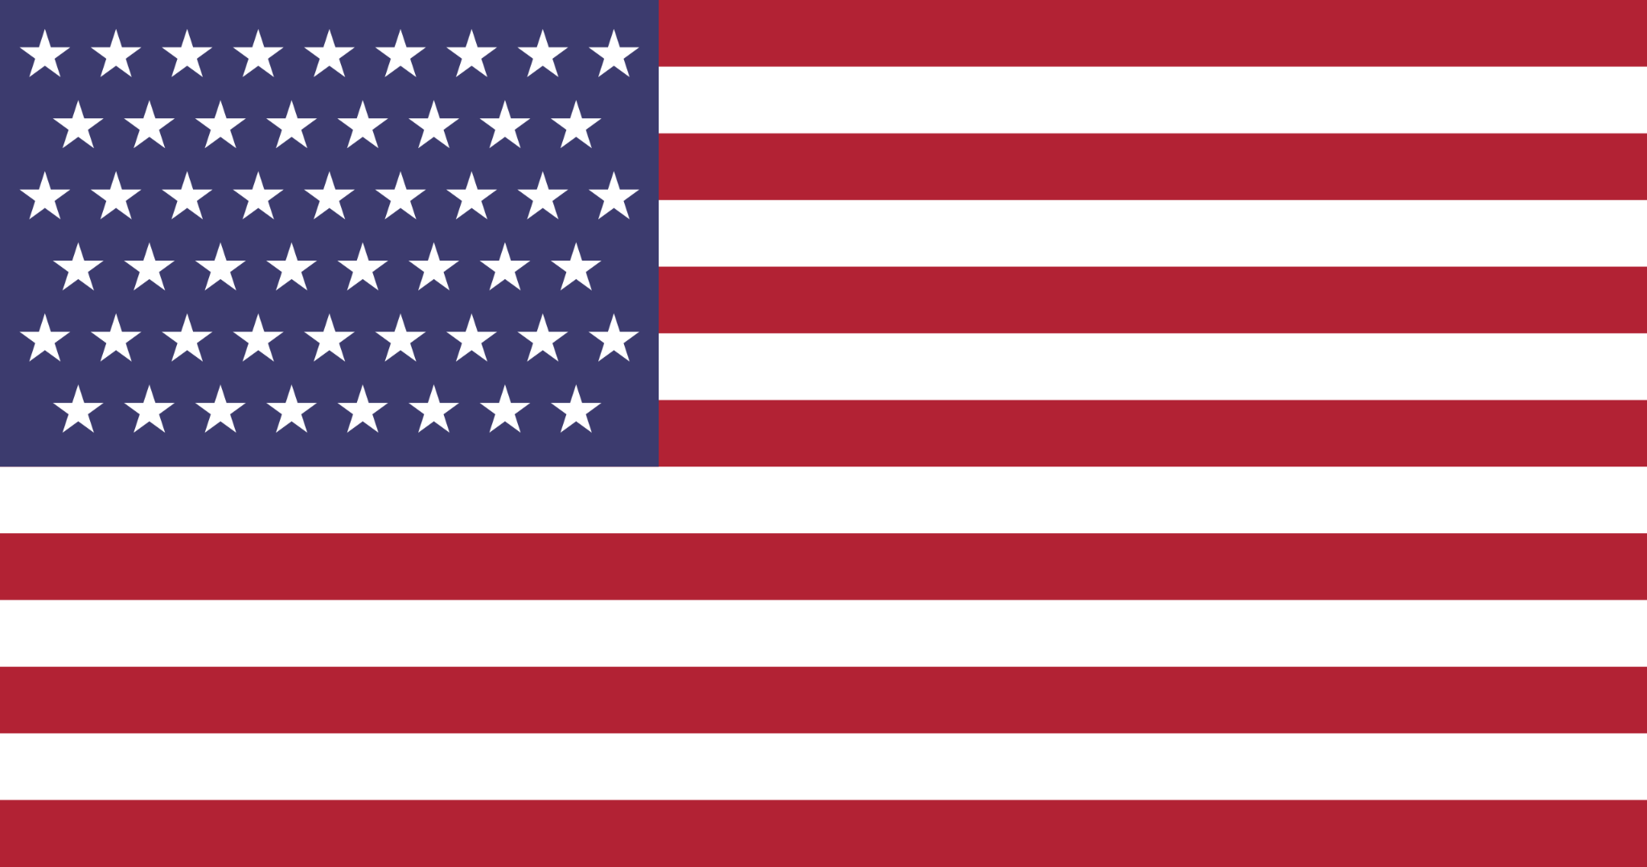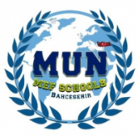

Country: United States of America
Committee: International Atomic Energy Agency (IAEA)
Agenda Item: Ensuring the Safe Handling of Radioactive Energy

ABOUT OUR COUNTRY: Our country - the United States of America- is located in North America. It comprises 50 states, a federal district, five major unincorporated territories, nine Minor Outlying Islands, and 326 Indian reservations. The United States is also in free association with three Pacific Island sovereign states: the Federated States of Micronesia, the Marshall Islands, and the Republic of Palau. It is the world's third-largest country by both land and total area. It shares land borders with Canada to its north and Mexico to its south and maritime borders with the Bahamas, Cuba, Russia, and other nations With a population of over 333 million, it is the most populous country in the Americas and the third most populous in the world. The national capital of the United States is Washington, D.C. We have a constitutional federal republic type of government that is governed by our president Joe Biden since 2021.

In the United State of America, The Nuclear Waste Policy Act of 1982 established a timetable and procedure for constructing a permanent, underground repository for high-level radioactive waste by the mid-1990s, and provided for some temporary storage of waste, including spent fuel from 104 civilian nuclear reactors that produce about 19.4% of electricity there. The United States in April 2008 had about 56,000 tonnes (120 million pounds) of spent fuel and 20,000 canisters of solid defense-related waste, and this is expected to increase to 119,000 tonnes (260 million pounds) by 2035.

According to this information we are honored to state that President Obama established the Blue Ribbon Commission on America’s Nuclear Future (the commission). The commission, composed of fifteen members, conducted an extensive two-year study of nuclear waste disposal, what is referred to as the "back end" of the nuclear energy process. The commission established three subcommittees: Reactor and Fuel Cycle Technology, Transportation and Storage, and Disposal. On January 26, 2012, the Commission submitted its final report to Energy Secretary Steven Chu. In the Disposal Sub Committee's final report, the Commission does not issue recommendations for a specific site but rather presents a comprehensive recommendation for disposal strategies. During their research, the Commission visited Finland, France, Japan, Russia, Sweden, and the UK. In their final report, the Commission put forth seven recommendations for developing a comprehensive strategy to pursue.

Also, our country has an agency called, the United States Environmental protection Agency (EPA) The EPA is responsible under the Atomic Energy Act for developing general environmental standards that apply to both the Department of Energy (DOE)-operated and the U.S. Nuclear Regulatory Commission (NRC)-licensed facilities that use radioactive material. Other statutes provide the EPA with the authority to establish standards for specific wastes or facilities. These include the Nuclear Waste Policy Act, Waste Isolation Pilot Plant Land Withdrawal Act, and the Energy Policy Act of 1992, which affect the development and implementation standards for the management and disposal of waste at certain disposal facilities; the Uranium Mill Tailings Radiation Control Act (UMTRCA) that enables the EPA to set limits on radiation from mill tailings; and the Clean Air Act that limits radon emissions from mill tailing impoundments. The EPA has developed safety training for workers who could come into contact with radioactive material and radioactive wastes. Workers and managers in any of the industries that produce radioactive waste can take this training to learn more about recognizing and properly disposing of radioactive wastes.

There are five near-surface Low-level radioactive waste (LLW) disposal facilities in operation in USA ; Texas Compact facility near the New Mexico border, operated by Waste Control Specialists; Barnwell, South Carolina; Clive, Utah; Oak Ridge, Tennessee – all operated by Energy Solutions; and Richland, Washington – operated by American Ecology Corporation.
High‐level radioactive waste (HLW) disposal policy in the USA since 1987 has focused on a site in volcanic tuffs 305 meters beneath Yucca Mountain, Nevada, with current plans calling for the repository to be opened in 2017.

We have some possible solution ideas for this issue; first of all, everything starts with health, and health is the key to all movements for solutions. In order to do this we suggest the nations create an organization for searching the possible dangers of radioactive wastes could create for their citizen's health. The economy is the other essential topic, in the UN there are a lot of undeveloped or currently-developing countries so some actions could pressure their economy in a bad way and it could affect all human beings' economies too.
On the other hand we need to join education, we should teach people how to handle this situation and have more professionals around. Education starts with kids so governments have to add the topic of “ Radioactive Energy and Wastes” to their curriculum for a more promising future. Last but not least we encourage the Member States to use social media effectively in addition to raising awareness about this significant problem.

