Country:Belarus 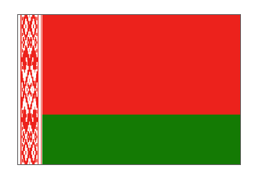
The Republic of Belarus is a country located in Central Europe (28-32° east longitude, 51-55° north latitude) with the territory of 207,6 thousand square km. It borders with Poland, Lithuania, Latvia, Russia and Ukraine. The total length of the state border is 2.969 km.
-Belarusian climate – is moderate continental, is influenced by air masses of the Atlantic. The hottest month is July, the coldest one is January. In general, 42% of the area of the country is under forest cover, 42% is covered by agricultural land, 6%- lakes, rivers and swamps. (10% – other lands). Birch and pine are the most frequently occurring tree species in Belarus.
-The largest in Europe old-growth forest area is located in Belarus. The age of some trees in Belovezhskaya Pushcha is about 600 years, they already existed when Columbus discovered America. Since 1992 Belovezhskaya Pushcha has been included in the World Heritage List.
- Belarus has more than 20,000 streams, with a total length of about 56,300 miles (90,600 km), and more than 10,000 lakes. The greater part of the republic lies in the basin of the Dnieper—which flows across Belarus from north to south on its way to the Black Sea—and the basins of its major tributaries, the Byarezina and Pripet on the right bank and the Sozh on the left. Among the largest lakes are Narach, Osveyskoye, and Drysvyaty.

