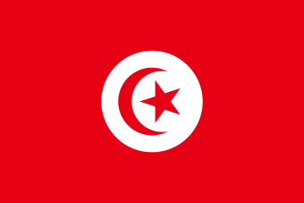
Committee: United Nations Office on Drugs and Crime (UNODC)
Topic: Money Laundering and Countering the Financing of Terrorism
Country: Tunisia
Delegate: Cemile Şener
Tunisia is committed to ending the money laundering, crimes that cause this problem, preventing and combating all forms of those crimes.In order to achieve this goal Tunisia has signed international agreements and started implementing measures in order them end domestically.Especially with Law No. 2003-75.Tunisia describes the financial activities subject to the AML/CFT measures and defines the core principles of prevention and detection as well as of compliance assessment:
- Customer identification,
- Establishment of an AML/CFT-related detection and audit system
- Role of financial sector supervisors in assessing compliance with the obligations, and
- Disciplinary and criminal penalties in cases of noncompliance.
Also Tunisia has been accepted for membership of Egmont Group in July 2012 and Tunisia will continue to work with MENAFATF (East and North Africa Financial Action Task Force) to improve further its AML/CFT regime. . In addition our country is proving that well aware of the impact of terrorism and the financing of terrorism by making legal arrangments.

The Middle East & North Africa Financial Action Task Force (MENAFATF) completed and assessment of Tunisia's measures to combat money laundering and terrorist financing.The assessment is a comprehensive review of the effectiveness of Tunisia's measures to protect the financial system from abuse and its level of compliance with the FATF Recommendations.
In February 2018, Tunisia was included on the Commission list of third countries with strategic deficiencies in their legal frameworks for anti-money laundering and counter-terrorist financing measures. It made significant progress in implementing the November 2017 Financial Action Taskforce (FATF) action plan. In October 2019, Tunisia’s reports were welcomed and decided the country would no longer be subject to the FATF's monitoring process under its ongoing global anti-money laundering and countering the financing of terrorism (AML/CFT) compliance process.
In conclusion Tunisia's domestic legal regulations and its involvement in international agreements show that it is suitable for counter financing of terrorism and tackling the money laundering. But in the age of information and technology, methods of financing terrorism are also globally developing. Considering new methods like anonymous digital payment systems ,falsifying invoices ; traditional effort in combating terrorism is inadequate.
Trends in terrorist financing like social media ,new payment products and services are new trend that have not been subject to TF study by the FATF.
Tunisia thinks United Nations should debate the technology affects to the money laundering and financing of terrorism.Tunisia determined to take any action quickly against financing of terrorism’s new trends .
As a solution:
Understanding the lack of technologically in regulations .
Create a security net regulation for countering financing of terrorism.
Tunisia values the work of this committee and hopes for a strong resolution.

