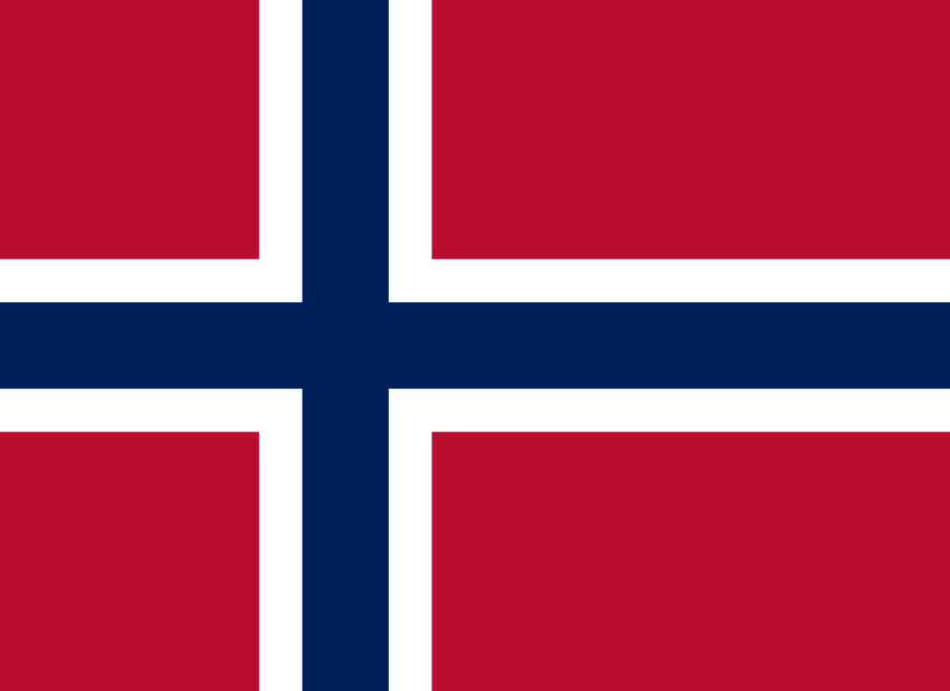
COMMITTEE: WHO
COUNTRY: Norway
DELEGATE: Sıla Hızlı
TOPIC: Responding to the Opposition to Vaccination
CONFERENCE: TEDUTRAIN’21
POSITION PAPER
Norway, officially the Kingdom of Norway, is a Nordic country in Northern Europe. The capital and largest city in Norway is Oslo. Norway has a population of 5,481,800. The country shares borders with Sweden, Russia and Finland. The official language in Norway is Norwegian.
Norway's health system -which cares most about the right to health- one of the most fundamental rights of its citizens- and does its best, accepts most vaccines, including the current Covid-19 vaccine, and encourages its citizens to vaccinate. In Norway, all vaccination is voluntary.
The recommended vaccination programme for children and adolescents includes vaccines against twelve different diseases: rotavirus, diphtheria, tetanus, whooping cough, poliomyelitis, infection with Haemophilus influenzae type b (Hib), hepatitis B, pneumococcal disease, measles, mumps, rubella and human papilloma virus (HPV), which can cause cervical cancer and other cancers cause by HPV. Some children are also offered vaccination against tuberculosis. All these diseases can be life-threatening or result in serious complications.
Vaccination usually begins when a child is six weeks old. Since several of the diseases vaccinated against affect the youngest children the hardest, delays should be avoided. Booster doses are given when a child reaches school age.
And, of course, due to the Covid-19 pandemic, which played a major role in shaping our lives after 2019, Covid-19 vaccines also took the most important place in the health system.
While 3.33 billion people worldwide have received all their Covid-19 vaccinations, Norway constitutes 3.86 million (71.7%) of them. Of course there are some reasons that effects the vaccination percantage.
One of them is the role of the culture. Culture is a very important element in the field of health as well as in social life, economy and many other fields. As the Norwegian people and government, we aim to live and raise conscious generations about vaccination. Although culturally anti-vaccine thoughts are not common, we do our best to ensure that the new generation is careful and attentive to such important issues.
The other one and maybe the most effective one; Social media, which is the environment of controversial issues, is also a very comprehensive and open environment for opinions on vaccine and anti-vaccine.
In Norway, which has a very careful and caring attitude about vaccination, the rate of anti-vaccination is quite low. The state has prepared informative texts, animated films and supports to encourage the public to vaccinate. In other words, Norway is an ideal country to respond to and find solutions to anti-vaccination.
Norway will be honored to be present at this conference to talk about the measures that can be taken to minimize anti-vaccination, the methods that can be applied to increase the reliability of the vaccine in the eyes of the citizens, the social campaigns that can be organized with the ideas of the participating countries and more.

SOURCES:
https://www.fhi.no/en/id/vaccines/coronavirus-immunisation-programme/
https://ourworldindata.org/covid-vaccinations?country=OWID_WRL
https://www.fhi.no/en/id/vaccines/
https://www.fhi.no/en/id/vaccines/childhood-immunisation-programme/
https://www.regjeringen.no/en/topics/koronavirus-covid-19/id2692388/

