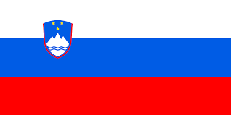
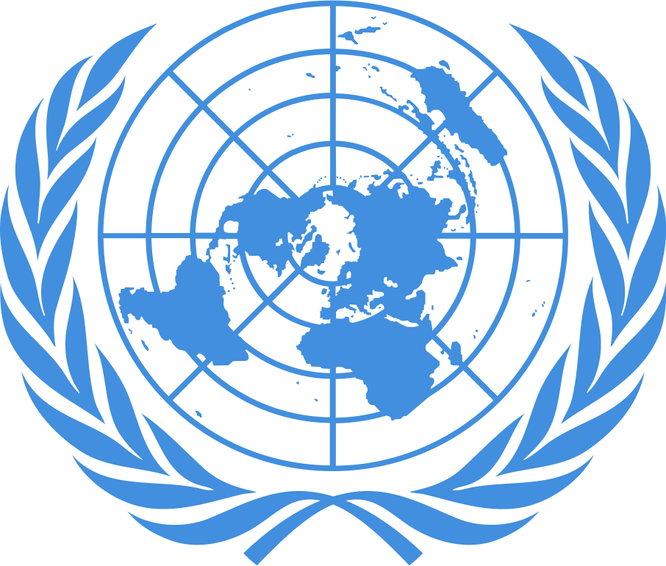
POSITION PAPER
Country: Slovenia
Committee: Historical NATO
Agenda Item: North Macedonia Ethnic Rivalry 2001-2003
Delegate: Umut Tekbaş
Slovenia is a country located in the south of Central Europe. It is bordered by Italy to the west, the Adriatic Sea to the southwest, Croatia to the south and east, Hungary to the northeast, and Austria to the north. Slovenia, once part of the Socialist Federal Republic of Yugoslavia, declared its independence on June 25, 1991 and became an independent state. It joined the European Union on 1 May 2004. It is the first country to enter the European Union from the disintegrating Yugoslavia. The second is Croatia. Slovenia means "Land of the Slavs" in Slavic. Slovenia became a member of NATO on 29 March 2004
At the end of 1990s, it was identified that the Albanian parties in the parliament did not sufficiently reflect the wants and needs of the Albanian people in Macedonia. The mixture of all these reasons and demands led to a crisis in 2001. Simultaneously, Albanians living in Macedonia had a battle with Macedonian security forces. OFA ( Ohrid Framework Agreement) is the most important development to evaluate the demands that cause ethnic conflict. After this conflict, the country encouraged to join the European Union.
There are 3 opeartions done by NATO Headquarters Skopje:
1- Opeartion Essential Harvest (22 August 2001)
2- Operation Amber Fox (27 September 2001)
3- Operation Allied Harmony(16 December 2002)
Slovenia supported NATO's actions towards North Macedonian crisis in 2001-2003. However, we did not send military support to the operations. When it comes to the possible solutions, we should search for ways to deal with the tension of the past with least amount of causalities. Additionally we should demonstrate a solution to the problem by discussing. The first step towards easing ethnic tension would be to get to the source of the causes and discuss ways of eradicate them.

