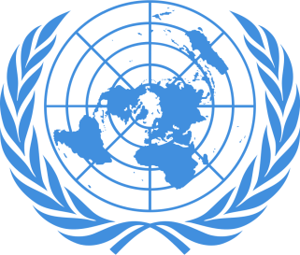
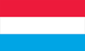
POSITION PAPER
Country: Luxembourg
Committee: Historical NATO
Agenda Item: North Macedonia Ethnic Rivalry 2001-2003
Delegate: Eray Berkin Ağdağlı

Luxembourg (officially The Grand Duchy of Luxembourg) landlocked country in Western Europe. It is bordered by Belgium to west and north, Germany to the east and France to the south. Its capital Luxembourg City, is one of the four official capitals of the European Union (together with Bruselss, Frankfurt and Strasbourg) and the seat of the Court of Justice of the European Union, the highest judicial authority in the EU. Luxembourgish is the only national language of the Luxembourgish people, as defined by law. Also Luxembourg is the one of the 12 founder countries in NATO.

At end of the 1990's, it was determined that the Albanian parties in parliament failed to adequately reflect the demands and needs of the Albanian people in Macedonia. The accumulation of all these reasons and demands caused a crisis in 2001, in which Albanians living in Macedonia had a battle with Macedonian security forces. OFA is the most important development put forward in the name of assessing the demands that cause ethnic conflict. After this conflict, the country had a incentive to join the European Union.
There are 3 opeartions done by NATO Headquarters Skopje:
1- Opeartion Essential Harvest (22 August 2001)
2- Operation Amber Fox (27 September 2001)
3- Operation Allied Harmony(16 December 2002)

Luxembourg supported NATO's actions towards North Macedonian crisis. However we did not send troops to the operations.If we have to search solution methods, we should look for ways to overcome the tension of the past with minimal causalities, as well as to demonstrate a solution to the problem The first step towards easing ethnic tension would be to get to the source of the causes and discuss ways of eliminating them.

