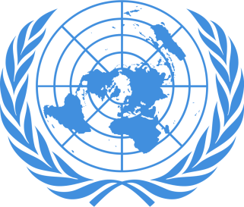
POSITION PAPER
Country: Poland
Committee: Historical NATO
Agenda Item: North Macedonia Ethnic Rivalry 2001-2003
Delegate: Emre Gül

Poland is a country located in Central Europe and It's divided to 16 administrative provinces. Poland has a population of nearly 38.5 million people and is the fifth most populous member state of the European Union. The country is bordered by Lithuania, Russia, Belarus, Ukraine, Slovakia, Czech Republic and Germany. Poland is a developed market and a middle power. It has the sixth largest economy in the UN. It provides very high standards of living and economic freedom. Poland became a part of NATO in 1999.

At the end of 1900's, it was determined that the Albanian parties in parliament failed to adequately reflect the demands and needs of the Albanian people in Macedonia. This opinion has led to the demand for Albanian parties that carry nationalism more dominantly. Those reasons and demands caused to a crisis in 2001 which Albanian Macedonians had a battle with Macedonian security forces. After this conflict, the country had an incentive to join the European Union.

There are three operations run by NATO headquarters:

1: Operation Essential Harvest (22 August 2001)
2: Operation Amber Fox (27 September 2001)
3: Operation Allied Harmony (16 December 2002)

The Policy of Poland was in line with NATO. We supported NATO for their actions. However we chose to not contribute about military forces. For the solution of the crisis, we are seeking ways to get over the tension of the past with minimal number of causalities, as well as to demonstrate a solution to the problem. The main solution for us towards easing ethnic tension is to determine the source of the causes and discuss about ways to exterminate them.

