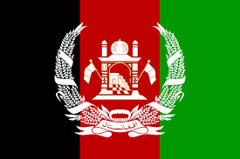
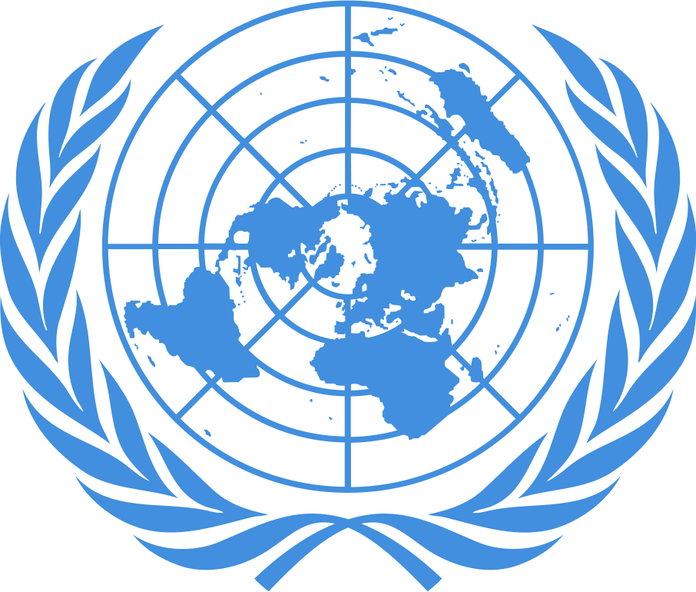
POSITION PAPER
Country: Islamic Emirate of Afghanistan
Committee: UN Women
Agenda Item: Elimination of the Raising Domestic Violence During Covid-19 Pandemic
Delegate: Mehmet Meriç Özgör
Afghanistan, or officially the Islamic Emirate of Afghanistan, is a landlocked country in the south of Central Asia. Pakistan in the east and south; Iran in the west; Turkmenistan, Uzbekistan and Tajikistan to the north; In the northeast, it borders with China. The total population of the country is about 34 million. Afghanistan has a GDP value of billions of dollars since 2014. Its annual revenue is 1.7 billion, its annual expenditure is 6.639 billion (since 2015).
Violence against women is a common human rights violation in many parts of the world. And unfortunately, this situation is quite common in our country. Women in Afghanistan are oppressed in every way and subjected to various tortures. It is not easy to be a woman in Afghanistan. On the one hand, women who are under pressure to join the society and on the other not to leave the house, are confused about what to do.
The Declaration on the Elimination of Violence against Women or DEVAW is a 1993 United Nations (UN) resolution that specifically addresses violence against women and the elimination of violence. The resolution generally complements and strengthens the International Convention on the Elimination of All Forms of Discrimination against Women (CEDAW) and the Vienna Declaration and Program of Action, which were adopted in 1979. As a result of the declaration, the United Nations General Assembly in 1999 25 November is designated as the International Day for the Elimination of Violence Against Women.
In the last hundred years, Afghanistan has been governed by different administration policies, and after the civil war that broke out after 1990, the Taliban administration gained the upper hand and the Islamic Republic was established. In fact, although women gained equality with the 1964 constitution, women were deprived of many rights with the transition to the rule of sharia. First of all, they are exposed to restrictions on their right to education, not being able to go out on their own, and not being able to pursue a profession other than being a doctor.
As a solution to this stopping, correct and humane education should be given to everyone in the country. people's welfare level should be increased and their security should be ensured. All restrictions on women should be lifted and all their rights should be restored.

