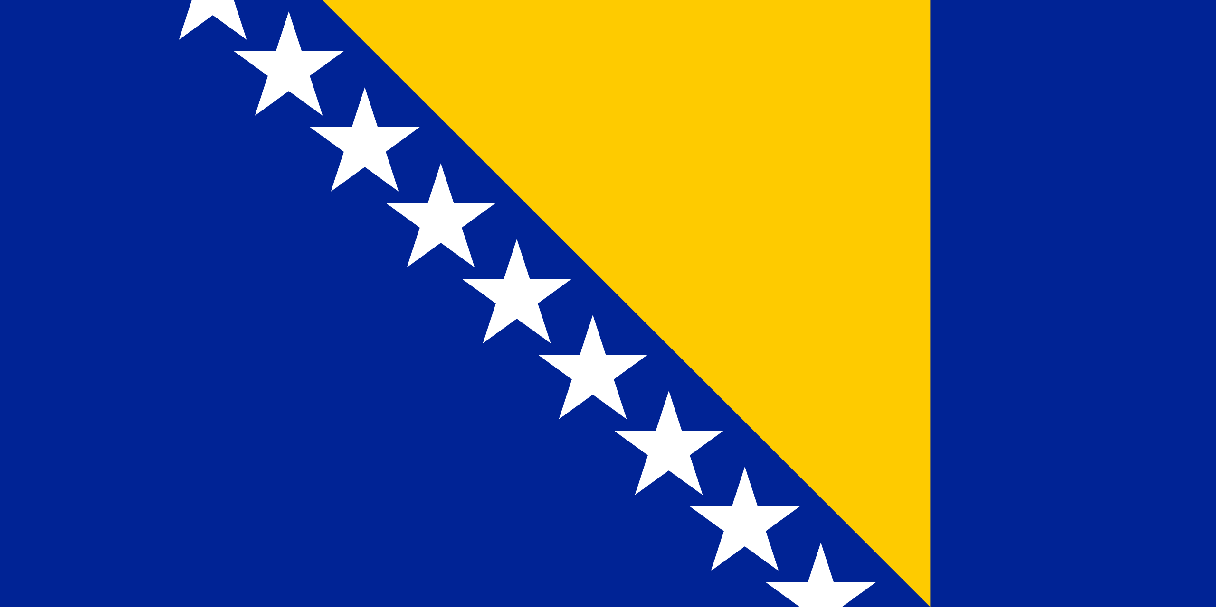
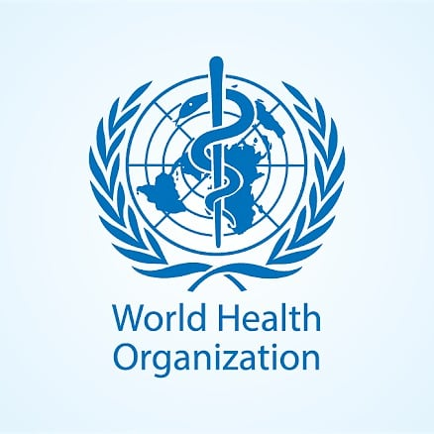Committee : WHO
Country : Bosnia and Herzegovina
It is a fact that COVID-19 is a virus that affects the whole world negatively on important issues such as education, health, economics, psychology and so on. Moreover, it puts the states in a difficult situation. All people, including the people of Bosnia and Herzegovina, have mobilized to treat this virus, which affects the whole world.
The COVID-19 pandemic and its economic consequences have had a relatively high impact on Bosnia and Herzegovina’s population and economy. Bosnia and Herzegovina has experienced several waves of the pandemic. The authorities acted quickly to control the virus during the first wave of the pandemic . The first case of COVID-19 was reported on 5 March 2020 and the first death on 21 March. A state of emergency was declared in late March. By 1 May, there were a total of 1,757 cases and 68 registered deaths, compared to 9 registered deaths per million in Albania and 13 per million in both Kosovo and Montenegro. Authorities in Bosnia and Herzegovina acted quickly to contain the spread of the virus, yet future health resilience is not guaranteed. The COVID-19 vaccination campaign in Bosnia and Herzegovina is a mass immunization campaign that was put in place by the Bosnian authorities in order to respond to the ongoing COVID-19 pandemic. It started on 12 February, 2021. As of 29 January 2022, 943,394 people have received the first dose, 846,080 people have received the second dose and 135,476 people have received the third dose.
Bosnia and Herzegovina's Council of Ministers approved new rules and conditions for the entry of foreigners to the country. Accordingly, people who have been vaccinated or have undergone coronavirus disease will be able to enter the country without a negative PCR test. Antigen tests at Bosnia and Herzegovina's border crossings will also be accepted. Until now, citizens of Serbia, Croatia and Montenegro were able to enter the country without a PCR test. After the start of face-to-face education in primary schools, the introduction of more intensive use of closed spaces in restaurants and cafes due to the cooling of the weather, and the almost complete disappearance of mask use in the public, it was observed that citizens in Sarajevo mostly complied with the regulation introduced. Due to the increase in the number of cases, especially in Sarajevo, citizens are expected to restrict their movements, not to go to indoor environments such as shopping malls and restaurants as much as possible, and to pay attention to social distancing.
As a conclusion, as Bosnia and Herzegovina, we think that people should continue to wear masks even if corona virus finishes. Precautions while travelling should be the same. We are ready to found institutions worldwide via the help of other countries that will work on the viruses which can be dangerous for people’s health and prevent them before becoming widespread like COVID-19. Also, people must be careful about the hygiene as they do during the COVID-19 process. Workplaces and schools should be organized to avoid the spread of viruses. We believe we can control the spread of the illnesses like that.

