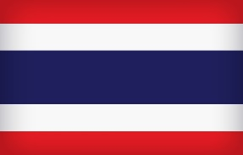
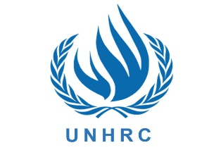
Country : Thailand
Committee: UNHRC
Delegate : Elif Azra Keser

Refugee crisis is one of the most important affair around the world. Thailand has been struggling with many refugee crisis because of Thailand's geographical locations and border neighbors for many years. Thailand is localized to the north by Myanmar and Laos, to the east by Laos and Cambodia, to the south by the Gulf of Thailand and Malaysia, and to the west by the Andaman Sea and Myanmar. Thailand also shares maritime borders with Vietnam to the southeast, and Indonesia and India to the southwest. Thailand attracts the attention of many refugees and countries both because of its living opportunities and its geographical location.
Thailand has been a country that always has problems on refugee crisis for years. As a consequence of Vietnam-ABD war and Myanmar civil war the influx of refugees the far east to Thailand started in the early 1950's. Between 1950 and 1980, a total of 4,5 thousand Vietnamese became IDP and refugees in the Thailand. After Myanmar civil war, about 1,2 million Myanmarese DP refugees came to Thailand. Although Thailand formerly permitted Burmese refugees to live in Bangkok, in the late 1990s, the government ordered them to move to the border camps. Most remained in Bangkok in hiding. Beginning in April 2001 and continuing throughout 2002, Thai officials went to the Burmese refugee camps in Tak Province, near Mae Sot, to promote "voluntary repatriation." The officials specifically targeted persons rejected for admission to the camps and new arrivals, as well as Burmese residing outside the camps. The government reported that more than 1,000 asylum seekers accepted about $14 per person (600 Thai Baht) and returned to Burma during 2002. The government conducted no similar repatriation efforts in the other camp areas. UNHRC said there were some spontaneous returns, but doubted their permanence because of continued violence in Burma. The Thai Government refused to provide education kid refugees and suggested that they go to their country.Thailand rejected to support refugees because Thailand would have to spend high on refugee care (housing, employment, education, and healthcare), including healthcare. Refugees are causing increases in food and house prices and property rents. Also, low-wage refugees would increase the unemployment rate. Besides one of the most important impact of refugees is on security.When the refugees came to the country, the people were nervous because they were not sure about the safety of life and property.
UNHRC has been present in Thailand since 1975, and won its second Nobel Peace Prize in 1981 in part for its humanitarian and non-political efforts in South East Asia arising from the “boat people” crisis which impacted not only Thailand but the entire region. In 1998, the RTG requested UNHRC’s assistance for the protection of refugees from Myanmar on the Thai/Myanmar border. At present, Thailand continues to host some 91,363 refugees (as of February 2022, under reverification) from Myanmar in the nine RTG-run temporary shelters on the Thai/Myanmar border, in addition to approximately 5,000 urban refugees and asylum-seekers from over 40 countries, and some 480,000 persons registered by the RTG as stateless.

