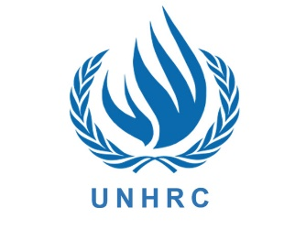
Country : Pakistan
Committee: UNHRC
Delegate : Nilsu Öztürk
Refugee crisis and the situations of refugees have been a common problem of humanity for ages. Almost all countries all over the world have been suffering from this problem as well as Pakistan. Because of sharing its borders with People’s Republic of China, Afghanistan, India and Iran, Pakistan has mostly affected by the conflicts that has occurred in Afghanistan. Afghan people fled to Pakistan after all the conflicts in their country.

Pakistan hosts more than 1.4 million registered Afghans who have been forced to flee their homes. In 2018, UNHRC’s work in Pakistan includes working with the authorities to give refugees access to health and education services, strengthening social cohesion between refugees and their host communities and helping refugees who decide voluntarily to return home. Pakistan has a coast on the Arabian Sea and Gulf in the south. It borders India to the east, Afghanistan to the west, Iran to the southwest, and China to the northeast.

With the Soviet intervention in late 1979, it became evident that the crisis would not be resolved in the short term. UNHRC established a permanent office in Pakistan in January 1980 and started what was to become “the largest assistance programme ever undertaken”. Eventually, there were up to around three million Afghan refugees in Pakistan. Beyond the supplying of relief goods like shelter, clothing, food and fuel, UNHRC’s activities ranged from providing building material for the camps and water supply, to veterinary services for the refugees’ about 3 million livestock and non-material assistance like education and training.

How can we empathize with refugees and make them feel like they are in their own country? For example, Pakistan can do these things: We can find a way to use your specific skill to help refugees or employ refugees or shop at stores that employ refugees. If refugees cannot work, we should offer them chances to volunteer, encourage universities in communities to offer refugee scholarships,help refugees integrate into an unfamiliar culture, know the history of refugees in the United States,organize fundraising and awareness events in communities.

