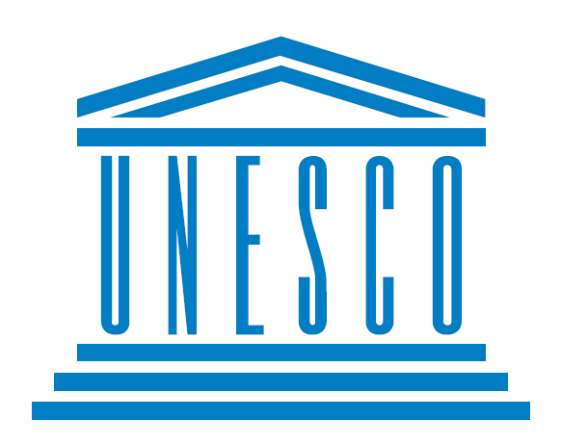

Country : Japan
Committee : UNESCO-2
Delegate : Zeynep Semra KÖSE

Education is significant for the whole world. Since education has a very important place in the development and growth of children, we must continue education in any case. Today, as the delegate of Japan, we say that education is an issue that cannot be interrupted and will always continue, regardless of the situation. We know that because Japan is exactly on the fault line, earthquakes happen frequently. In addition, since Japan is surrounded by the Pacific Ocean, it is an island country. In this case, unfortunately, many tsunamis occur in Japan. In crises like these, we find it very necessary to continue education.

Wars are one of the biggest obstacles to education. For example, there were times when there were obstacles to education in Japan. In the Pacific War in December 1941, people's lives turned into a war-centered life. Children were no exception and were included in the war regime regardless of their will. At such times, children were learning hard because there was no education. Then rigorous training was done using a new national textbook and military training (naginata training for girls, rescue training, nursing training) with wooden weapons.

Child labor is a barrier to education. In child labor, children are recruited into wars, threatened or otherwise. During the war times, children are employed as soldiers, porters, messengers, and assistants, and they take away their right to education and put obstacles in front of education. Poverty is a barrier to education. Since the countries affected by the wars are under colonial rule, children cannot go to school. Parents of children who cannot afford school fees, school meals, books, and stationery do not send their children to school, putting another obstacle in the way of education.

We are here to pave the way for education in conflict-affected countries and we believe we will solve these problems. Since children cannot go to school in war-affected areas, children cannot receive an education. To eliminate this problem, we can do the following; of course, after ensuring the safety of the people first, we can train the children by giving certain hours of the day to education in the shelters so that the children can receive an education.
The psychology of children in wars deteriorates, and on top of that, they are threatened and made to work in wars. In the end, children cannot receive an education. To prevent these situations, it is necessary to take precautions in advance, for example, in these cases, we can take precautions as follows: If we provide an education where children can defend their rights by opening special courses established by governments every month, children will know their rights in the future and will be able to use their rights to education.

