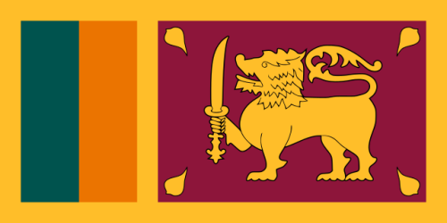
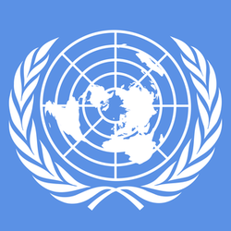
Fighting Against Social Exclusion and Child Poverty
Country: Sri Lanka
Committee: UNICEF 2
Delegate: Ege Ünsal
Sri Lanka or officially the Democratic Socialist Republic of Sri Lanka is an island country in South Asia, 31 kilometers south of India and located in the Indian Ocean. Before 1972, it was known as Ceylon. About 21 million people live in the country, which is also called the Pearl of the Indian Ocean.

Getting an education is the right of every child. But unfortunately, there are children in Sri Lanka who cannot receive these educations. UNICEF has been supporting the rights and

well-being of children in Sri Lanka since the early 1950’s. In the early years of life, an environment of nurturing is crucial to the mental stimulation, social interaction and positive life skills young children need to develop and grow. Today, Sri Lanka’s preschool sector is largely unregulated. Many children do not receive the quality preschool education they need to enter primary schools and ultimately succeed in their lives. To address disparities and gaps in the preschool sector, UNICEF is working with government and private partners towards a system that supports and assures quality preschool education for all children in Sri Lanka.

Social and cultural norms that tolerate emotional, physical and sexual violence against children exist throughout Sri Lanka. Over the past three decades, UNICEF has been working with the Sri Lankan government to strengthen the child protection system .

Sri Lanka's common law does not allow underage marriages. The legal age is 18. But a decades-old community law called the Muslim Marriage and Divorce Act (MMDA) allows Muslim community leaders, who are mostly men, to decide the marriage age.

