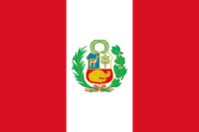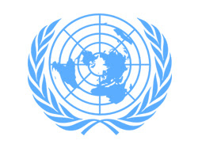
Fighting Against Social Exclusion And Child Poverty
Committee: UNICEF 2
Country: PERU
Delegate: Zeynep Semra KÖSE

Peru, country in western South America. Except for the Lake Titicaca basin in the southeast, its borders lie in sparsely populated zones. The capital of Peru is Lima. Economical state, education system, geographical location has a big role on reflecting a country’s development. In Peru, the rights of children are fulfilled to a varying degree. On one hand, the country has made real material progress in improving the lives of young Peruvians. On the other hand, only some children can take advantage of these advances, and many others are left behind, with no guarantee that their rights will be respected.
UNICEF foresees the preparation of the Peruvian National Strategy on Violence Against Children. In addition, its duties and authorities will continue to be supported in order to ensure effective and efficient specialization in the public sector. Although poverty rates have reduced during the last 15 years, Peru is still one of the countries in Latin America with the highest level of income inequality. Nearly one out of two Peruvians lives in poverty – three out of five in the case of children – and one out of five is extremely poor. Although Peru has these kind of problems in terms of economy, it is forty-seventh country in the world .
Child marriage is one of the biggest problems of the world. This problem has many bad effects on children’s mental states. Peru is one of the countries that suffers from this problem severely. Almost every girl under the age of eighteen gets married. Especially, child marriage is one of the biggest psychological problems of the girls.
UNICEF has taken some measures against child violence and poverty in Peru. These measures are penalties and administrative fines. One of the country’s greatest achievements is to decrease chronic child malnutrition currently at 13.1 per cent.

