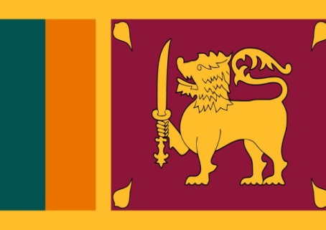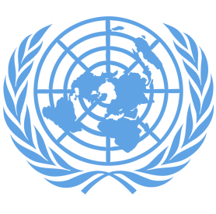
Fighting Against Social Exclusion and Child Poverty
Country: Sri Lanka
Committee: UNICEF 1
Delegate: Neda İnce

The Democratic Socialist Republic of Sri Lanka, previously known as Serendib or Ceylon, is an island in the Indian Ocean to the South East of India with an area of about 65600 square kilo-meters (almost the size of the Republic of Ireland) and a population of around 20 million.

Child poverty is very important and general problem. Child poverty is a broad phrase used to refer to a wide range of issues that impact children’s capabilities, wellbeing and future potential. This multidimensional perspective also recognises that children are individuals rather than extensions of a household or a family and that their experiences of poverty and well-being are different to those adults.Health and nutrition are the fundamental building blocks of children’s lives and their growth into healthy and productive adults.
Sri Lanka can be proud of its achievements in this area. Immunization coverage is now universal, under-five mortality rates are in decline, and access to safe water and improved sanitation facilities has improved nationwide. However, many gaps still exist and much work remains to be done to achieve an environment in which all children can be guaranteed good health and rapid development in line with the standards set by the UNICEF.

