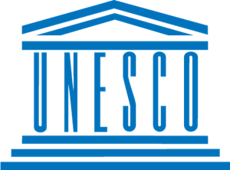
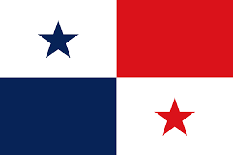
Barriers to Education in Conflict-Affected Areas

Country: Panama
Community:Unesco
Delegate: Zeliha Zümra Akoğlu

War is a civilizational decline that has been happening all over the world since the beginning, both for political and social reasons.It causes many basic rights of people to be restricted, from the right to health to the right to travel.One of these is education. But if we don't educate a new generation, how can society move forward!
As in the whole world, the days of war have passed in Panama. Thousand days war, banana wars and more...Among those who lost their lives in these battles, not only adults, but also children were among the decimated. Child soldiers, ignorant children, dead donuts and more. However, most of the wars in Panama have dec between countries other than Panama, and Panama has been caught in the crossfire.
In other countries, the situation is not much different.Battles of the First and Second world wars, Samnite wars, Thirty years wars, Battles and more. What about the kids? Children who don't want to fight, who want to read, play, and have fun. But in wartime, people again realize the value of life and think that things other than living are insignificant.
It is for these reasons that the war should be put an end to.At least for battles with a rifle, with a cannon. Because sending students to other countries from the battlefield is only a temporary solution. Therefore, the sociology of war should be changed. Problems should be solved by mutual sacrifices under the line of logic, and new laws should be established about this for the Future and for the World.

