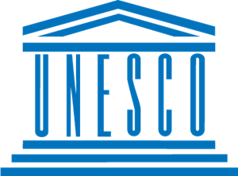
Barriers to Education in Conflict-Affected Countries

Country:Argentina
Committe:UNESCO
Delegate:Işıl Ayla Bayhan

As it is known that world war is getting bigger and because of this war education is not being succesfully. Argentina has been one of the richest states in the world since the 1870s thanks to its rich underground resources and availability of agricultural activities. Economic prosperity in the country dec Argentina an immigration center, especially between 1870 and 1930.Italian and Spanish immigrants who came to the country during this period made up about 90% of the country's population, which was 45,376,763 in 2020.
Argentina is a federal country, but education and other areas have been traditionally organised in a very centralised manner. The relatively high levels of literacy, education attainment and social democratisation that the country had achieved by the mid twentieth century were reversed to a significant extent by the joint effects of the last military dictatorship (1976-1983) and the economic crisis of the 1980s. During the last two decades, the reconfiguration of the educational system, including its adaptation to new challenges posed by local and global forces, has been an important issue in the public arena. We consider the concept of educational quality as an ‘empty’ or ‘floating signifier’ which means different things to different people. The vagueness of the concept has been pointed out by different authors in the fields of comparative education and education planning (Pedró & Puig, 1998; Casassus, 1999; Santos Guerra, 2003; Myers, 2006). We analyse the reform policies and how the discourses of the national government, local academics and international organisations have addressed the concept of educational quality. We focus on three moments: (1) the emergence of the discussion about quality (at the end of the 1980s); (2) the enactment and implementation of the Federal Law of Education (1993); and (3) the enactment of the Law of National Education (2006), along with the implementation of some key policies.
In order to cope with this problem, education can be continued in a quiet place away from war or from online education, but if such a place and country is under threat, they can continue education in underground shelters or by watching pre-made educational videos.

