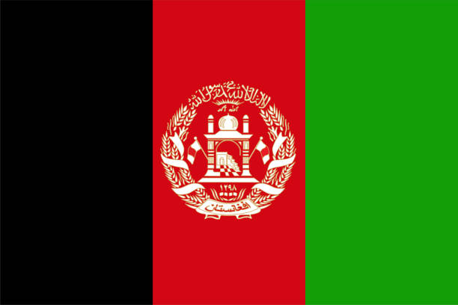
Country: Afghanistan
Committee: World Health Organization (WHO)
Topic: Adolescent Health in Underdeveloped Countries

As the delegate of Afghanistan, we accept that adolescents are a important part of the community that will be shaping our future and represent us worldwide. Adolescents make up a quarter of Afghanistan's population. And we see that number as a significant percentage. The discrimination and inequality that people have to suffer in our society, highly affect adolescents directly or indirectly by their mothers. Because of the inattentive and insufficient health services and conditions that offered to woman, lots of them are dying during or after labor. This case is ledding an unstopable increase in infant mortality.

Adolescents that born in Afghanistan have to face multiple challenges since they opened their eyes to the world. This challenges are often caused by poverty, lack of education or gender inequality. The war with America, which has been going on since 2001, probably affects the young population of the country the most. The war did not only collapse Afghanistan economically, but also made the country almost uninhabitable For adolescents. Many children gave up their education to earn money for their families and began to take on the responsibilities of hard work that they could not do. some even aimed to earn money by trying to go illegally to different countries. But rather than making money for them, it caused them to be misunderstood and misrepresented to the state and the outside world. This period of time and the events experienced have been very challenging mentally for many adolescents. Since those years, the incidence of psychological disorders such as psychiatric disorders, emotional anxieties, behavioral problems and post-traumatic stress disorder has increased in the youth of the country. In the last few years, under the leadership of the Afghan Ministry of Public Health, UNICEF has been working with a number of actions aimed at providing better health services to children, andadolescents and vaccination across the country.

In conclusion, although Afghanistan has followed an incorrect or incomplete policy on adolescents health issue until now, it does not remain indifferent to this growing problem and aims to take action in cooperation with other states. We believe that education is primarily the building block of individuals who make up the state, and education is one of the methods we want to use when solving this problem. We believe that we can eliminate this problem by providing the right information and opportunity, starting with adolescents who are just starting to know themselves and looking at life from different perspectives, and then raising their families and public awareness.
References:
https://www.unicef.org/afghanistan/health
https://www.unicef.org/afghanistan/media/2151/file/afg-publication_adolescents-in-Afghanistan.pdf.pdf
https://jamanetwork.com/journals/jamanetworkopen/article-abstract/2793513

