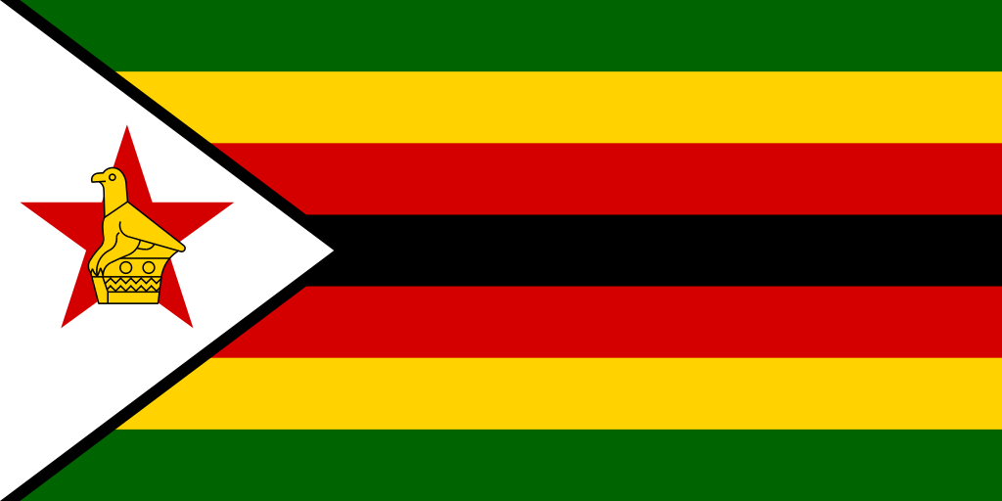
Committee: United Nations Environment Programme
Topic: Enhancing the transition to sustainable energy as a response to the energy crisis and climate change
Country: Republic of Zimbabwe
Delegate: İdil Göksel

The Republic of Zimbabwe is a landlocked country located in Southeast Africa, between the Zambezi and Limpopo Rivers, bordered by South Africa to the south, Botswana to the south-west, Zambia to the north, and Mozambique to the east. The capital and largest city is Harare. The world’s giant curtain of falling water Victoria Falls is located in the northwest Zimbabwe. Since Zimbabwe’s climate is sub-tropical, gets lots of sun and rainfalls at the same time, the potential for green renewable energy is enormous. That is why Zimbabwe is one of the African countries that hopes renewable energy technologies will help to address their energy problems.

The energy crisis that started with the Covid-19 pandemic and continued with the Saudi Arabia-Russia oil price war and especially with the Ukraina-Russia war, is affecting so many people with causing an imbalance in the supply-demand chain. It doesn’t take much to see that our energy needs over the past few decades have soared, and we are reliant on fossil fuels whose been on the wane for past years. Overconsumption of our natural resources specifically of fossil fuels such as oil, gas, and coal, which can put a strain on our water and oxygen resources by causing pollution. To the current statistics, we only have oil reserves for 40 years, about 60 years’ worth of conventional oil and about 2 centuries' worth of coal reserves. Another cause of the crisis is the growing population of the world and their demand for energy. According to the International Energy Agency (IEA), global energy demand could increase by more than 50% by 2030. Ageing infrastructure of power generating equipment, while they are polluting and causing a significant increase in Co2 emissions, are also becoming increasingly close to resulting. There is a significant delay in making new power plants to reduce the gap between the demand-supply chain. When supply doesn’t match demand, it results in a system blackout. Poor distribution systems, major accidents and natural disasters, wars are reasons for the energy crisis too. Not enough usage of renewable energy is the most important cause of the energy crisis. Renewable energy sources can increase the usage of fossil fuels and also helps to reduce greenhouse gas emissions.

The Republic of Zimbabwe has a big energy crisis inside and many people are affected by that. Around just 40% of the population has access to electricity. They are very low statistics since the whole world needs electricity to live. Because of this situation, Zimbabwe works on renewable energy sources to produce energy.

Zimbabwe has a hydropower potential of 18,500 GWh a year, of which 17,500 GWh is technically possible. About just 19% of the technically possible potential has already been used. Kariba dam provides around 57 percent of Zimbabwe's electricity and with the proposed Batoka Gorge Hydroelectric Power Station, Zimbabwe cooperating a project with Zambia around the Zimbezi River about hydroelectric power. Solar power has enormous potential, such as water heating or such as in solar power plants. However, Zimbabwe's current economic condition makes sufficiently immediate solar power buildups seem unrealistic. A project in partnership with the United Arab Emirates will result in the structure of a 2,000 MW solar power plant. If it will be completed it would be the largest solar plant in the world. Animal power is important in the country because of the agricultural sector. Fuelwood is the major source in rural areas. For cooking, lighting and heating, over 80% of the population mainly uses fuelwood. But fuelwood using causes environmental problems such as erosion and diminishing wildlife. Biomass is generally plant-based waste used as fuel to heat or electricity. More than 200 biogas plants have been installed in Zimbabwe, mainly by the Department of Energy. Zimbabwe has a target of supply with 10% of its fuel requirements through biofuels.

Zimbabwe has no gas or liquid diesel sources of its own. A little part of imports from Mozambique and the other imports from Southern Africa, because Zimbabwe is part of the Southern Africa Power Pool (SAPP). SAPP helps Zimbabwe with the electricity crisis too. Zimbabwe has so much coal underground and coal replaces a noted role in energy usage of the country. In September 2013, a Chinese company said it would begin work in early 2014 on a coal-fired electricity plant in western Zimbabwe, part of $2 billion energy projects in the country. But usage of coal is frightful for the environment and increases the emission of greenhouse gas, that's why Zimbabwe aims to transition to renewable energy.

With the Paris Agreement, Zimbabwe aims to resist climate change while pursuing its sustainable development agenda. Zimbabwe showed its Intended Nationally Determined Contributions (INDC) in September 2015. The main energy policy is National Energy Policy (2012). The aim is to provide the whole country’s electrical demand and find new, more cheap and specifically more nature-conscious sources. The main intense is to explore cooperation to develop large hydropower dams and also for oil and gas opportunities. In the not too distant future, it aims to develop coal and coal-bed methane. The policy focuses on five demand sectors: agriculture, industry and mining, commerce and services, transport and households (both urban and rural). The efficient usage of energy in executing economic activities and fuel-wood substations are the important elements of the policy.

The National Renewable Energy Policy (2020), the policy which is Zimbabwe’s key document for the usage of renewable energy in rural and urban places aims to increase renewable energy’s role in the energy mix by creating persuasions for supply, to demand. The Biofuels Policy of Zimbabwe (2020) fosters sustainability in the country, especially ethanol from sugar cane and biodiesel from jatropha, until 2030. Focuses are reducing greenhouse gas emissions and putting an order on oil imports. The requests of the policies are to achieve a 33 percent reduction in greenhouse carbon emissions by 2030. President Emmerson Mnangagwa said "This will go a long way towards Sustainable Development Goal number 7 which seeks to ensure affordable and clean energy," Renewable energy has been a good option and preferable energy throughout the world."

The Republic of Zimbabwe sees Climate Change as a serious problem. The Government signed the United Nations Framework Convention on Climate Change in 1992 at the Rio Earth Summit and approved it in November of the same year. Generally, the problems climate change brings are related to water supply and food security. The country is already prone to droughts and this makes it defenseless to changes in the water supply. Zimbabwe's effect on global emissions of greenhouse gas is so small but there is a concern about potential damages from climate change on the country in the future. The enormous usage of rain-fed agriculture, lack of natural lakes, periodic occurrence of droughts in the region and a growing population shows Zimbabwe can reach devastating impacts from climate change.

In this conference, Zimbabwe aims to clarify the transition to renewable energy by debating solutions and start resolving the energy crisis to come to a better situation for energy problems in the world. Climate change needs to stop, and this can be provided by us accelerating the transition to renewable energy, developing our policies and informing the population of humanity about potential damages.

References:
https://www.enovaenergy.com.au/energy-crisis#:~:text=The%20energy%20crisis%20is%20a%20result%20of%20many%20different%20strains,oxygen%20resources%20by%20causing%20pollution.
https://en.wikipedia.org/wiki/2021%E2%80%932022_global_energy_crisis#:~:text=The%202021%E2%80%932022%20global%20energy,Kingdom%20and%20China%2C%20among%20others.

https://en.wikipedia.org/wiki/Batoka_Gorge_Hydroelectric_Power_Station
https://en.wikipedia.org/wiki/Southern_African_Power_Pool
https://wedocs.unep.org/bitstream/handle/20.500.11822/20589/Energy_profile_Zimbabwe.pdf?sequence=1&isAllowed=y
https://climate-laws.org/legislation_and_policies?from_geography_page=Zimbabwe&geography%5B%5D=200&type%5B%5D=executive
https://www.adaptation-undp.org/explore/eastern-africa/zimbabwe
https://energypedia.info/wiki/Zimbabwe_Energy_Situation#cite_note-12
https://en.wikipedia.org/wiki/Energy_in_Zimbabwe#:~:text=Zimbabwe%20has%20one%20hydropower%20plant,population%20have%20access%20to%20electricity.
https://www.zera.co.zw/petroleum-2/
https://www.zera.co.zw/electricity1/

