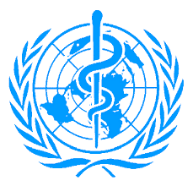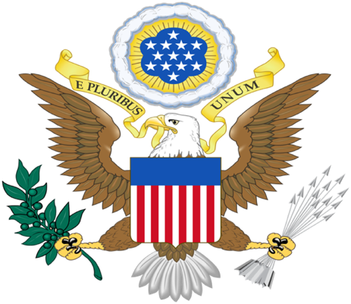

Committee: World Health Organization (WHO)

State: United States of America

Agenda Item: Responding to the Opposition to Vaccination

Delegate: Rovshana Ismayilova

Institution: Ankara University, Faculty of Law

The WHO's main objective is "the attainment by all peoples of the highest possible level of health"[1] and, as the largest economy, the United States of America has always been extremely honored to take an active role in World Health Organization for decades. We have faith in finding a solution on such an important issue as the Opposition on Vaccination.

The Covid-19 virus that was first identified in Wuhan, China, in December 2019 caused significant casualties because humanity was not prepared to deal with a pandemic. There were a lot of conspiracy theories, complicated thoughts about the pandemic period, vaccines.

The United States has approximately 330 million population and 0.4% population growth for every year. Because of the large population, immunization programs need regular regimes to control the process. With various vaccination programs, we are providing certain vaccinations free of charge. With the development of the first efficient vaccine of polio, in 1955, the US Congress invested funds in the Centers for Disease Control and Prevention to help states purchase and vaccinate. Centers for Disease Control and Prevention (CDC) set immunization schedules with the recommendations from Advisory Committee on Immunization Programs (ACIP). The ACIP includes 15 voting members; members include clinical medical fields, public health, and a consumer representative. In the United States, with these programs, especially the rate of Vaccine-Preventable Disease decreased or even disappeared.

Certain religious, cultural beliefs strengthen anti-vaccination tendencies. Disinformation is also one of the reasons for this type of actions. Internet and media are the best sources for sharing information and following the news. The problem with the media is that people can spread fake statements effortlessly. The web is full of conspiracy theories, false information about vaccines and, this is also a significant reason for rejecting vaccines. One of the religious groups opposing vaccination is Christian Nationalism; they makeup 20 percent of the population of the United States. Christian Nationalist beliefs consist that they are chosen people of God and they are going to be protected by God. As they make up a significant percentage of the population, the US takes action to inform the public with campaigns and projects. We prevented approximately 140.000 deaths and 3 million cases by our early Covid-19 vaccination campaign.

The USA believes that vaccination is one of the most effective public health interventions in the world for promoting good health. With a vaccination rate of 71 percent, the United States of America states that we acknowledge the safety, importance of vaccination. In US states with the strictest laws, the rates of diseases are significantly lower. As the land of freedom, we think that mandatory vaccination should be compulsory for children and healthcare personnel. We assume that if we work in collaboration with other delegates we can make planet earth healthier.

Page J, Hinshaw D, McKay B (26 February 2021). "In Hunt for Covid-19 Origin, Patient Zero Points to Second Wuhan Market – The man with the first confirmed infection of the new coronavirus told the WHO team that his parents had shopped there". The Wall Street Journal. Retrieved 27 February 2021.
Census Bureau QuickFacts. 2019. U.S. Census Bureau QuickFacts: United States. [online] Available at: https://www.census.gov/quickfacts/fact/table/US/PST045219
Data.worldbank.org. 2020. Population growth (annual %) - United States | Data. [online] Available at:https://data.worldbank.org/indicator/SP.POP.GROW?end=2020&locations=US&start=1961&view=chart
Centers for Disease Control and Prevention. 2021. COVID-19 Vaccination. [online] Available at: https://www.cdc.gov/coronavirus/2019-ncov/vaccines/no-cost.html
Lauren Roper, Mary Ann Kirkconnell Hall, Amanda Cohn, Overview of the United States’ Immunization Program, The Journal of Infectious Diseases, Volume 224, Issue Supplement_4, 1 October 2021, Pages S443–S451, https://doi.org/10.1093/infdis/jiab310
Centers for Disease Control and Prevention. 2021. Who Sets the Immunization Schedule?. [online] Available at: https://www.cdc.gov/vaccines/parents/schedules/sets-schedule.html
Cdc.gov. 2021. ACIP Current Membership Roster | CDC. [online] Available at: https://www.cdc.gov/vaccines/acip/members/index.html
Katie E. Corcoran, Christopher P. Scheitle, Bernard D. DiGregorio,Christian nationalism and COVID-19 vaccine hesitancy and uptake, Vaccine, Volume 39, Issue 45, 2021, Pages 6614-6621,ISSN 0264-410X, https://doi.org/10.1016/j.vaccine.2021.09.074.(https://www.sciencedirect.com/science/article/pii/S0264410X21012895)
Whaley, C., 2021. Early COVID-19 Vaccine Campaign in the United States Prevented Nearly 140,000 Deaths. [online] Rand.org. Available at: https://www.rand.org/news/press/2021/08/18/index1.html
Nytimes.com. 2021. See How Vaccinations Are Going in Your County and State. [online] Available at: https://www.nytimes.com/interactive/2020/us/covid-19-vaccine-doses.html

