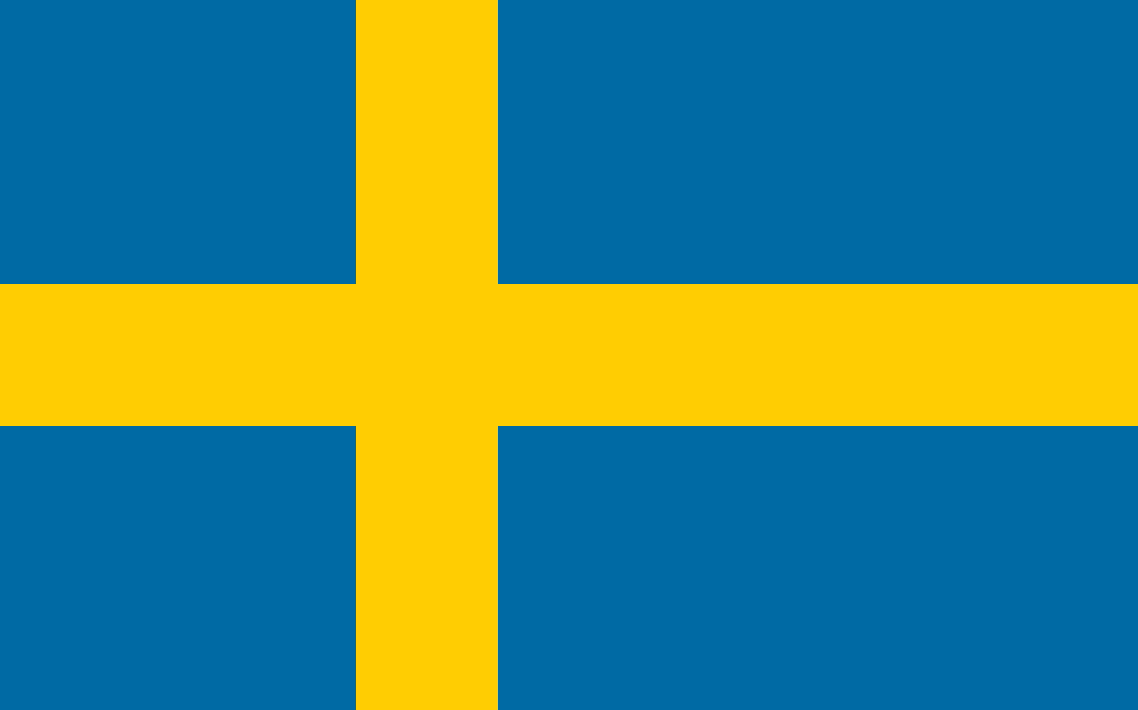
Committee: The Commission On the Status Of Women (CSW)
Country: Sweden
Topic: Recognition and Visibility of Transgender Women

Sweden is a country that has constitutional monarchy, takes place in Scandinavia, has a competitive and highly liberalized open market economy and comes into prominince to any issue that is directly or indirectly related to human rights. When homophobia and being a part of the LGBTQ+ community was considered as an illness in the world, Sweden was supporting them socioculturally, politically and economicly. Currently, Magdenela Andersson is the prime minister of the country who is the leader of Swedish Social Democratic Party and also a trans woman.

The government of Sweden is most likely to be considered as substantially consistent with trans women rights. They made increasingly progress throughout the years and were the first country in the world to allow sex reassignment surgery. Beacuse of trans people living in quite uncivilized conditions and struggling with mental health issues, Sweden published the Public Health Authority. This report shows that more than half percentage of trans people attempt suicide. People became more aware after those circumstances that trans people face everday came to the surface.

Being aware comes first, and that can only happen if we let go of the traditional beliefs, considerations and thoughts that we were taught. And see the person in front of us just the way they are, as a human being and just let them be. Our society has lots of deficits such as public restrooms do not include a gender neutral ones or for some people it is unacceptable to see a transgender women who was born a male in female restroom. There are so many ways to reach out to this part of the society where people are narrow minded .First by education and raising awareness through social media.We have to start foundations, hang billboards on the streets and organize pride parades annually. We can not prevent people to be who they want to be but we can change the perception of the society because tolerance is all it takes.

References:
https://sweden.se/life/equality/gender-equality

