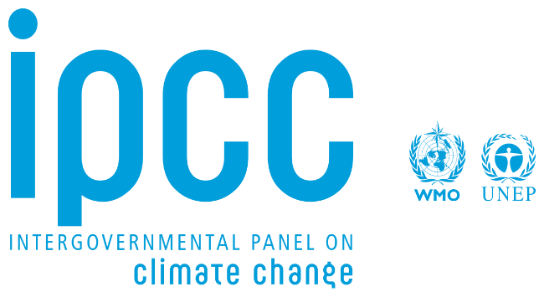

COUNTRY: BRAZIL
COMMITTEE: IPCC
DELEGATE: Mülkan ÜNVER
AGENDA ITEM III: Reducing climate change by protecting the Amazon forests, increasing renewable energy use, and supporting fair international cooperation

Climate change is a problem at the moment. Lots of countries effect this situation and people feel that in daily life. Weather conditions change and today's temperature higher than past's temperature Storms,floods etc. destraction of nature be. Animals and herbs increasing to disappear .This event is bad for people and animals. Brazil think climate changes is series problem and we should be helpful in this topic.
Brazil is developing country .It’s economy growing and has large population.Brazil has Amazon rainforests. Amazon is very important.Its helping for world climate and it absorbs carbon dioxide .So, Brazil important to protect forests.Brazil want to stop deforestation .Nature protect is important for Brazil. Moreover Brazil support renewable energy.Example: solar,windy and water.
Brazil to support ‘’Common but Difference Responsibility’’ law. All countries take responsibility. But developed countries take more responsibility.Because developed countries to be more pollution in the past. Also, this countries have more technology and Money at today .Developing countries need development.In the process, someone support this countries.
Brazil believe to necessarry workship.Countries work together. Renewable energy projects ,protect forest and financial support are important.Climate change is global problem and it can’t be solve alone.

REFERENCES
Intergovernmental Panel on Climate Change (IPCC). (2023). AR6 Synthesis Report: Climate Change 2023. Geneva: IPCC.
Intergovernmental Panel on Climate Change (IPCC). (2022). AR6 Working Group III: Mitigation of Climate Change. Geneva: IPCC.
United Nations Framework Convention on Climate Change (UNFCCC). (2015). The Paris Agreement. Bonn: UNFCCC.
Government of Brazil. (2023). Brazil’s Nationally Determined Contribution (NDC) under the Paris Agreement. Brasília: Ministry of Foreign Affairs.
United Nations Environment Programme (UNEP). (2023). Emissions Gap Report 2023. Nairobi: UNEP.
International Energy Agency (IEA). (2023). Renewables 2023: Analysis and Forecast to 2028. Paris: IEA.
United Nations Development Programme (UNDP). (2022). Climate Change Mitigation and Sustainable Development. New York: UNDP.

