
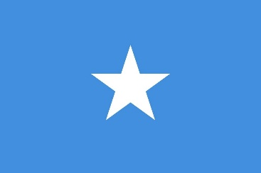
Country: The Federal Republic of Somalia
Committee: The Special Political and Decolonization Commitee
Agenda Item: Administration of Cultural Heritage
Delegate: Candan Uyan

The Federal Republic of Somalia has a rich and diverse cultural heritage.Somalia is home to numerous archaeological sites,monuments, and intangible cultural heritage.Somalia has been shaped by different periods.The country’s cultural heritage plays a vital role in national soverginity and identity .However, the rich cultural heritage has been threatened by Somali’s prolonged internal conflict, looting and illicit trafficing as well as natural disasters.Especially, the capital city of Mogandishu’s cultural heritage was ruined, and fifty percent of the buildings destroyed during the armed conflicts.Protection of these cultural heritages both important for Somalia’s national value and future generations.
Somalia preserves and develops its national cultural heritage both through its own efforts,via SOMASA (The Somali Academy of Science and Arts) and through international collaboration with UNESCO.Somalia ratified two important UNESCO cultural agreement for The UNESCO Convention Concerning the Protection of the World Cultural and Natual Heritage (1972) and the Convention for the Safeguarding of the Intangible Cultural Heritage.Following the armed conflict,Somalia has begun the reconstruction of cultural sites and takes precations for safeguarding with the UNESCO’s conventions
In consequence,The Federal Republic of Somalia’s apporach on this issue is clear:to rebuild and protect our cultural heritage damaged by the decades of armed conflict.We plan to organize educational programs to raise awarness among the local people about administration of cultural heritage and to cooperate with international organizations such as,UN and UNESCO for its protection and restoration of destroyed archeological structures.

SOURCES
https://www.unesco.org/en/articles/somalia-ratifies-two-major-unesco-cultural-conventions
https://somalia.un.org/en/102819-somalia-develops-national-strategy-culture
https://www.ohchr.org/en/documents/country-reports/somalias-cultural-rights-landscape-enabler-peace-and-inclusion
https://www.hornheritage.org/mogadishus-vanishing-heritage/

