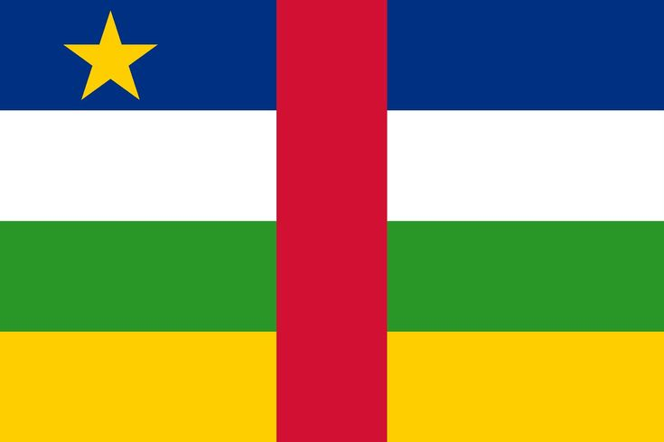
Committee: UNWOMEN
Country: Central African Republic
Agenda item: Strengthening Protection Around Women's Fundamental Rights In The MENA Reigon
Delegate: Bilge Yoldaş
As the delegation of the Central African Republic we're aware that women in MENA faces numerous challenges, including femicide, violence, discrimination, gender-based inequality, economic inequality and limited access to education. we recognize that empowering and protecting women's fundamental rights in MENA region is essential for peace, social stability and development. Enen though Central African Republic is not in the MENA region we have have experienced political instabilities, sexual violence against women lack of access to education and healthcare due to this we know the importance conference, believing that conflict-affected regions requires cooperation and support. We also believe that the solutions that'll be decided here can also help other countries which are struggling with similar problems. Central African Republic supports international frameworks aimed at eliminating discrimination against women such as CEDAW and Beijing Declaration and Platform for Action. Central African Republic proposes UNWOMEN the following solutions:
• legal protection by reforming laws to ensure gender equality and protect women from any type of violence and discrimination
• instead of focusing only to open more schools we can also promote the education programs to raise awareness about women’s rights and gender equality, targeting both women and men.
• We also strongly believe that increasing cooperation between UN agencies to provide technical and financial support is really important .

