 | Protecting Women in the Age of Digital Abuse: Regulating Al, Deepfakes, and Online Gender-Based Violence. | 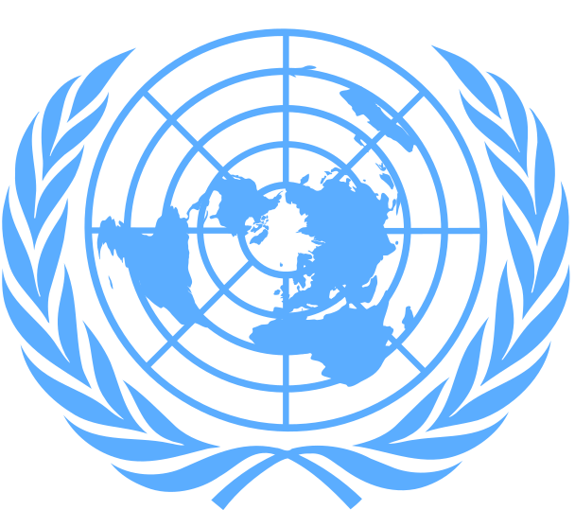
Committee: UN Women
Country: Republic of Ghana
Delegate: Elif Kışlabayrak

Ghana , officially Republic of Ghana formerly Gold Coast, Country, West Africa. Area: 92,098 sq mi (238,533 sq km). Population: (2025 est.) 33,512,000. Capital: Accra. Ghana is home to Akan, Mossi, Ewe, and Ga-Adangme peoples. Languages: English (official), Akan, Ewe, Hausa. Religions: Christianity (Protestant, other Christians, Roman Catholic), traditional beliefs, Islam. Currency: cedi.Ghana has a developing mixed economy based largely on agriculture and mining. Cacao is the mainstay of the economy; mineral exports include gold and diamonds. Ghana is a unitary multiparty republic with one legislative house; its head of state and government is the president.
“Digital violence,” or in a broader sense “technology-facilitated genderbased violence,” refers to any act that is committed, assisted, aggravated, or amplified by the use of information communication technologies or other digital tools that results in or is likely to result in physical, sexual, psychological, social, political, or economic harm, or other infringements of rights and freedoms. Like all forms of gender-based violence, digital violence is also a human rights violation and a result of inequalitiesBy deepening the digital divide, digital violence restricts access to information and services and violates women’s right to participate equally in public life. The rapid development of artificial intelligence makes it easier to spread misinformation and targeted disinformation. In addition, AIgenerated fake images (deepfakes) and non-consensual content are on the rise. According to Sensity AI data, 90–95 per cent of fake videos online consist of non-consensual sexual imagery, and about 90 per cent of these target women. According to UNESCO research, 73 per cent of women journalists have been subjected to online violence. According to data from the InterParliamentary Union, 81.8 per cent of women politicians have been subjected to online harassment, and 44.4 per cent have received threats of sexual or physical violence.
Ghana has joined the global community to mark the 2025 16 Days of Activism Against Gender-Based Violence, with the national launch held on 25 November 2025 in Accra. The Ministry of Gender, Children and Social Protection (MoGCSP) is leading this year’s campaign under the theme “Unite! End Digital Violence Against Women and Girls.” Ghana has the Domestic Violence Act, 2007 (Act 732)-a landmark piece of legislation that criminalizes all forms of domestic abuse. As the physical abuse migrated online, Ghana's legal response matured with the Cybersecurity Act, 2020 (Act 1038). The Act established the Cyber Security Authority (CSA), a body mandated to regulate cybersecurity activities. The CSA's functions now include promoting the online protection of women, the elderly, persons with disabilities, and underserved populations. This institutional focus ensures that the safety of vulnerable groups, including women, is an explicit part of the national cybersecurity strategy, leading to targeted public awareness campaigns and collaborations with organizations like CAMFED to train young women on digital safety. This legislation is a potent new weapon, recognizing that digital violence is not "harmless trolling online," but a grave human rights violation that silences women and restricts their public participation. Heavy Penalties: The Act specifically criminalizes several offenses that disproportionately target women and girls, carrying significant penalties that demonstrate the severity with which the state views these digital abuses.

References:
https://turkiye.unwomen.org/tr/digital-library/publications/2025/12/dijital-siddet-teknoloji-destekli-toplumsal-cinsiyete-dayali-siddet-rehberi
https://sikamantimes.com/govt-launches-2025-campaign-against-digital-violence-on-women-girls/
https://www.modernghana.com/news/1451167/double-the-battle-why-ghanas-fight-to-end-violence-again.html
https://theghanareport.com/stop-digital-violence-against-girlswomen/

