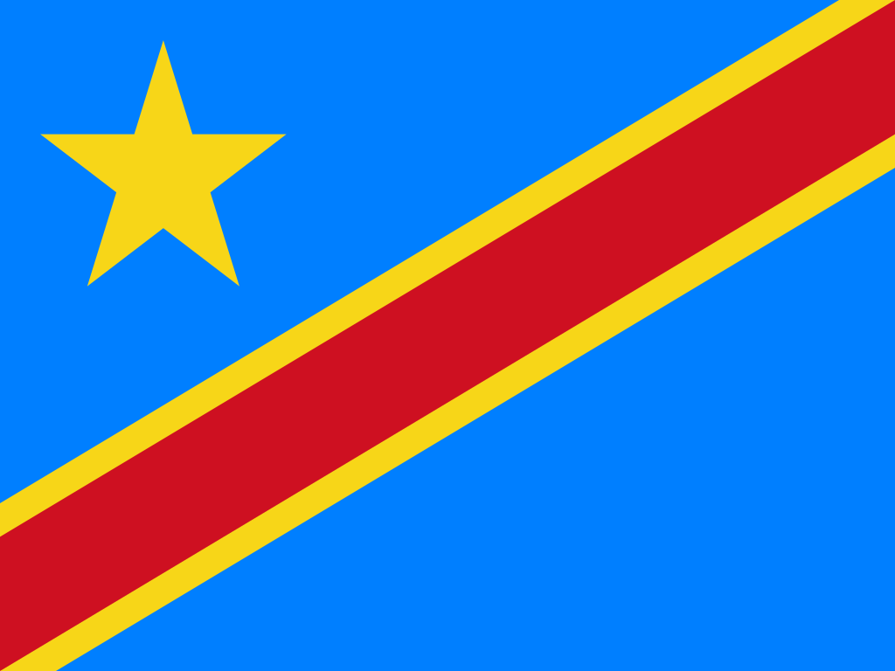
Committee: World Health Organisation
Topic: Preventing the Second COVID-19 Wave in the Africa Region
Country: Democratic Republic of Congo
Delegation: Deniz AKKİRPİ
Position Paper
The Democratic Republic of Congo, which has the second largest surface area of the African continent located in the Central Africa, northeast of Angola. The capital city of the country is Kinshasa. The country has borders to Angola, Burundi, Central African Republic, Republic of the Congo, Rwanda, South Sudan, Tanzania, Uganda and Zambia. The country has a total land border of 10,370 km. The Democratic Republic of Congo also has 40 km of coastline in the Atlantic Ocean. Languages ​​spoken in the country are: French, Lingala, Kikongo, Swahili, Tshiluba. According to the July estimates, DRC’s population is 101.780.263. The young population makes up about sixty-five percent of the country. According to researches conducted since 2014 in the country of the Democratic Republic of Congo, the literacy rate of the population between the ages of 15 and 49 is 75.9%, and the majority of this rate are men. The education system is managed by three government ministries, primary education is not free or compulsory. As a result of the six-year civil war in the late 1990s, in the early 2000s, more than 5.2 million children in the country did not receive any education. Since the end of the civil war, the number of children enrolled in primary schools increased from 5.5 million in 2002 to 13.8 million in 2015, and the number of children enrolled in secondary schools rose from 2.8. According to UNESCO, it reached 4.6 million in 2015. The school attendance rate has also increased substantially in recent years, with net primary school attendance estimated at 82.4% in 2014 (82.4% of children aged 6-11 have attended school; 83.4% for boys and 80.6% for girls). In the Democratic Republic of the Congo, medical impossibilities caused by financial insufficiency are experienced at an extreme level. There is no system that prioritizes the health of the people of the country, and the few hospitals in the country have become unusable due to years of civil wars. The number of patients per doctor in the country is around 10,000 and one of the biggest causes of health problems in the country is shown as not being able to find clean water. While only 29% of the people in rural areas have access to clean water, this rate is expressed as 82% in cities. Due to the fact that sewage is not common throughout the country, diarrhea, high fever as well as malaria, sleeping sickness caused by tsetse fly are common in the country.
The Democratic Republic of Congo is considered one of the richest countries in the world in terms of natural resources; Unprocessed raw mineral deposits are estimated to exceed US $ 24 trillion. Despite such great mineral wealth, the Democratic Republic of Congo's economy has plummeted since the mid-1980s. Congo citizens are among the poorest people in the world. The Democratic Republic of Congo is the world's largest producer of cobalt ore and a major producer of copper and diamonds.
What is a virus?
Viruses are known as the simplest organisms that can reproduce themselves. It consists of a protein layer surrounding molecules called DNA or RNA, which only carry its genetic structure.
What is coronavirus?
Coronavirus Disease (COVID-19) is a virus that was first detected as a result of research conducted in a group of patients who developed respiratory symptoms (fever, cough, shortness of breath) in Wuhan Province in late December on January 13, 2020. The outbreak was initially detected in the Huanan Seafood Wholesale Market in this region. It then spread from person to person and spread to other cities in Hubei province, especially Wuhan, other provinces of the People's Republic of China and other world countries. Coronaviruses are a large family of viruses that can cause disease in animals or humans. According to a report published on 25.03.2020, the state of kinshasa, where all cases were seen, was quarantined, and the president Tshisekedi noted that all travel between Kinshasa and other provinces was prohibited until a second order.
In a statement, the Minister of Health of the Democratic Republic of Congo, Eteni Longondo, stated that the person who was detected to have the virus lived in France and was a Congo citizen who returned to Congo on March 8. Minister Longondo stated that the patient in question and other people with him were also quarantined. Telling citizens not to panic, Minister Longondo warned them to regularly wash their hands and keep at least 1 meter distance from people with cough.
Small shops were closed together with official institutions and organizations for a certain period of time and a curfew was imposed for a short time. Ebola virus, which continues in the process of corona virus (Ebola virus causes a febrile disease in which 50% to 90% of cases that cause life-threatening hemorrhages result in death) also threatened people's lives. As a result of the measures taken for the country; Papy Pungu, Deputy Minister of Water Resources and Electricity of the Democratic Republic of the Congo, said in a statement that the application aims to reduce the public's expenses as part of the new measures taken to combat the Covid-19 outbreak.
While the National Electricity Company and Water Distribution Company confirmed the decision, it was noted that the necessary work was initiated to provide free water and electricity to citizens.
In the Democratic Republic of Congo, 10,509 people have recovered and 305 people have died from a total of 11,211 cases involved in the epidemic process so far.
Of the 44.7 million cases worldwide, 30 million recovered and 1.18 million died.
DRC, which entered the normalization process, was first opened to official institutions and organizations with caution, and it was also allowed to be opened by tradesmen on the condition that precautions are taken.
Secondary schools, high schools and universities, which were closed in the Democratic Republic of Congo (DRC) within the scope of combating the coronavirus epidemic, were opened to senior students. President Felix Tshisekedi said in the first lesson he went to a school in the capital, Kinshasa, that ''the epidemic is not yet over and therefore he asked students to respect the measures taken.''
Health measures taken worldwide:
Frequently clean your hands with soap, water or alcohol test disinfectant.
Keeping a safe distance from people.
Avoid touching your eyes, nose or mouth.
If you have fever, cough, and difficulty breathing, seek medical attention.
Using a mask.
It seems that these measures are not enough. What should be taken in addition to these measures, what should be done before and after ...
First of all, the world was not ready for this kind of epidemic because even the precautionary curfews were short-lived because the countries were not prepared to keep them afloat. During this epidemic, the opening of tradesmen, schools and café-style entertainment venues extended the process without controlling the epidemic. The underestimation of the coronavirus, especially in developed countries, has been effective in prolonging the pandemic process. If we think about what to do. Without a cure for the virus around the world, everyone had to create their own safe environment and disinfect all environments for a long time to listen to the calls of the states and prevent the virus. First of all, production areas would have to be increased in order to be able to reproduce virus test kits worldwide. Each country should visit its own people at home, identify viruses personally and familyly, and every positive case should be contained in their home, severe cases should be accommodated and treated in hospitals.
For the Democratic Republic of the Congo, corona virus and ebola virus cases have a largely fatal effect on humans, as cleanliness and health remain in the background due to the economy. As a precaution, people living in rural areas and cities should have access to water through water wells and dams.
A system that prioritizes public health should be developed in the country, and the few health centers and hospitals in the country should be increased. Public awareness should be increased and food and medicine supply should be increased with financial means due to the poor water and food consumption and the increase in the number of starving people, which are the basic needs of protecting the public from the virus.
We expect the supply of medicines from health institutions and request financial support from developed countries and the World Central Bank.

