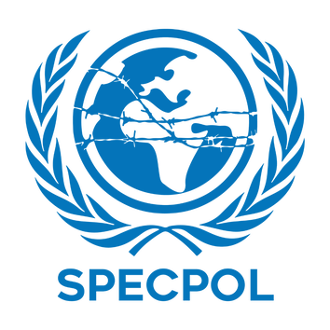


COUNTRY : INDONESIA
COMMITTEE : SPECPOL
DELEGATE : Emine GÜLDOĞAN

AGENDA ITEM : Administration of Cultural Heritage

Acording to the Republic of Indonesia, administration of cultural heritage has big challanges. These are illegal selling, climate change and no equality in digital things. Especially, illegal trade of historical object is a big problem. Also, the climate crisis gives damage to historical places. And digital inequality is a very important issues. These are the main problems. The Jakarta government says these issues hurt the cultural indentity of developing nations. This is a serious situation for many countries. Therefore, Indonesia calls for stronger international laws in the SPECPOL. For Jakarta, the main goal is important. Developing countries must not only protect their heritage. Indonesia believes they must also be the decision-makers.

About technology, Indonesia believes digital tools like AI and 3D modeling are very helpful. These tools protect cultural treasures for the future. Indonesia thinks this is very important. However, there is a sensitive point here. Every society has a special culture. ‘One size fits all’ protection models are not always successful. Because of this, Indonesia says technology must respect local feelings and sovereign rights. Digital information is very private. Indonesia believes digital data should not be a tool for digital colonialism. The national government must always control this information.

In coclusion, Indonesia wants a clear system. International committees must help with technology and digital museums. New investments and projects must protect the rights of local people. Also, they must not conflict with ethical values. Indonesia asks for this to solve the crisis. Indonesia believes that local plans and high technology can help tourism and protect human rights.

REFERENCES

UNESCO. (2021). Operational Guidelines for the Implementation of the World Heritage Convention: Addressing Climate Change and Cultural Property. Paris: UNESCO.
https://whc.unesco.org/en/guidelines/
​Republic of Indonesia, Ministry of Foreign Affairs. (2023). Indonesia's Position on Global Cultural Governance and Digital Sovereign Rights. Jakarta: Kemlu Press.
https://kemlu.go.id/404
​United Nations SPECPOL. (2022). Protection of Global Cultural Heritage: Tackling Illegal Trade and Digital Colonialism. UN Doc. A/SPC/77/L.14.
https://docs.un.org/A/SPC/77/L.14
​Jakarta Institute of Arts. (2024). The Ethics of Digital Archiving: Local Sensitivities and Global Technology. Jakarta: IKJ Press.
https://aucjc.ro/wp-content/uploads/2024/07/aucjcm-10-60-66.pdf
​United Nations General Assembly. (2019). Return or Restitution of Cultural Property to the Countries of Origin. UN Doc. A/RES/73/130.
https://docs.un.org/en/A/RES/73/130
ATUMUN’26 Study Guide. (2026). SPECPOL Committee Background and Agenda Items.

