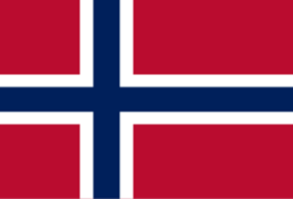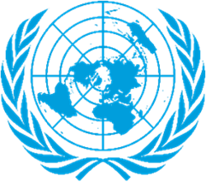

Committee: Special Political and Decolonization Committee (SPECPOL)
Agenda Item: Reassessing the Political Status of Disputed and Non-Self-Governing Territories
Country: Kingdom of Norway
Delegate:Zeynep Naz Şener
The effects of colonialism remain visible in international politics through unresolved conflicts and the continued existence of Non-Self-Governing Territories. Although there has been remarkable progress since the adoption of the UN General Assembly Resolution 1514 (XV), there still exist territories that are ruled by a colonially regulated system or have a state of ambiguous sovereignty. This has been witnessed by instances such as the Chagos Archipelago, Western Sahara, and New Caledonia. The Special Political and Decolonization Committee has an important role to play in this regard.

Norway gives particular importance to international law and considers the advisory opinions of the International Court of Justice to be essential in the process of decolonization. In this context, Norway supports the implementation of the ICJ’s 2019 advisory opinion on the Chagos Archipelago and calls for full respect for the rights of the displaced people affected by this issue.
Although Norway maintains constructive relations with administering powers such as the United Kingdom and the United States, it opposes the continued existence of colonial systems on security grounds. Norway believes that long-term stability cannot be achieved through military or legal means alone.

Norway recommends referenda supervised by the UN to ensure they are free, fair, and inclusive, giving the people a chance to select either independence, association, or integration in line with Resolution 1541 (XV). Moreover, Norway recommends improving UN mechanisms of monitoring in order to respect human rights while undergoing the process of decolonization.
In addition, Norway promotes mediation and confidence-building measures between the claimant states and the administrative powers, and prior concern should also be given to the indigenous people, whose voice has traditionally remained at the margins of the territorial dialogue.

